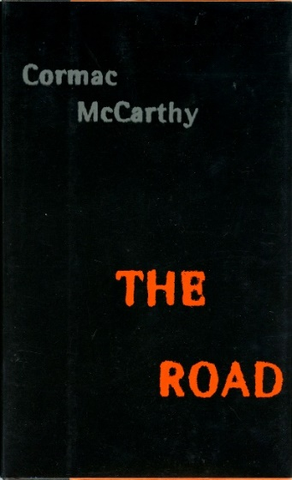
The Road by Cormac McCarthy, written in 2006, is a post-apocalyptic story about a father and son venturing across the ruins of America after an extinction event.
Back in the house he chopped at the wood around the haspstaple and finally jammed the blade under the staple and pried it up. It was bolted through the wood and the whole thing came up lock and all. He kicked the blade of the shovel under the edge of the boards and stopped and got his lighter out. Then he stood on the tang of the shovel and raised the edge of the hatch and leaned and got hold of it.
Papa, the boy whispered.
He stopped. Listen to me, he said. Just stop it. We're starving. Do you understand? Then he raised the hatch door and swung it over and let it down on the floor behind.
Just wait here, he said.
I'm going with you.
I thought you were scared.
I am scared.
Okay. Just stay close behind me.
He started down the rough wooden steps. He ducked his head and then flicked the lighter and swung the flame out over the darkness like an offering. Coldness and damp. An ungodly stench. The boy clutched at his coat. He could see part of a stone wall. Clay floor. An old mattress darkly stained. He crouched and stepped down again and held out the light. Huddled against the back wall were naked people, male and female, all trying to hide, shielding their faces with their hands. On the mattress lay a man with his legs gone to the hip and the stumps of them blackened and burnt. The smell was hideous.
Jesus, he whispered.
Then one by one they turned and blinked in the pitiful light. Help us, they whispered.
Please help us.
Christ, he said. Oh Christ.
He turned and grabbed the boy. Hurry, he said. Hurry.
He'd dropped the lighter. No time to look. He pushed the boy up the stairs. Help us, they called.
Hurry.
A bearded face appeared blinking at the foot of the stairs. Please, he called. Please.
Hurry. For God's sake hurry.
He shoved the boy through the hatch and sent him sprawling. He stood and got hold of the door and swung it over and let it slam down and he turned to grab the boy but the boy had gotten up and was doing his little dance of terror. For the love of God will you come on, he hissed. But the boy was pointing out the window and when he looked he went cold all over. Coming across the field toward the house were four bearded men and two women. He grabbed the boy by the hand. Christ, he said. Run. Run.
They tore through the house to the front door and down the steps. Half way down the drive he dragged the boy into the field. He looked back. They were partly screened by the ruins of the privet but he knew they had minutes at most and maybe no minutes at all. At the bottom of the field they crashed through a stand of dead cane and out into the road and crossed into the woods on the far side. He redoubled his grip on the boy's wrist.
Run, he whispered. We have to run.
He looked toward the house but he could see nothing. If they came down the drive they would see him running through the trees with the boy. This is the moment. This is the moment. He fell to the ground and pulled the boy to him. Shh, he said. Shh.
Are they going to kill us? Papa?
Shh.
They lay in the leaves and the ash with their hearts pounding. He was going to start coughing. He'd have put his hand over his mouth but the boy was holding on to it and would not let go and in the other hand he was holding the pistol. He had to concentrate to stifle the cough and at the same time he was trying to listen. He swung his chin through the leaves, trying to see. Keep your head down, he whispered.
Are they coming?
No.

Lord of the Flies by William Golding, written in 1954, is about a group of schoolboys who are abandoned on a tropical island after their plane is shot down during a fictional atomic war. Conflicts emerge between the boys as they struggle to build a civilization and fight for survival
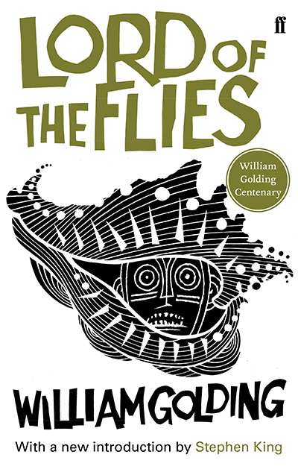
A procession had appeared, far down among the pink stones that lay near the water’s edge.
Some of the boys wore black caps but otherwise they were almost naked. They lifted sticks in the air together whenever they came to an easy patch. They were chanting, something to do with the bundle that the errant twins carried so carefully.
Ralph picked out Jack easily, even at that distance, tall, red-haired, and inevitably leading the procession. Simon looked now, from Ralph to Jack, as he had looked from Ralph to the horizon, and what he saw seemed to make him afraid. Ralph said nothing more, but waited while the procession came nearer. The chant was audible but at that distance still wordless.
Behind Jack walked the twins, carrying a great stake on their shoulders. The gutted carcass of a pig swung from the stake, swinging heavily as the twins toiled over the uneven ground. The pig’s head hung down with gaping neck and seemed to search for something on the ground. At last the words of the chant floated up to them, across the bowl of blackened wood and ashes.
“Kill the pig. Cut her throat. Spill her blood.”
Yet as the words became audible, the procession reached the steepest part of the mountain, and in a minute or two the chant had died away. Piggy snivelled and Simon shushed him quickly as though he had spoken too loudly in church.
Jack, his face smeared with clays, reached the top first and hailed Ralph excitedly, with lifted spear.
“Look! We’ve killed a pig—we stole up on them—we got in a circle—”
Voices broke in from the hunters.
“We got in a circle—”
“We crept up—”
“The pig squealed—”
The twins stood with the pig swinging between them, dropping black gouts on the rock. They seemed to share one wide, ecstatic grin. Jack had too many things to tell Ralph at once. Instead, he danced a step or two, then remembered his dignity and stood still, grinning. He noticed blood on his hands and grimaced distastefully, looked for something on which to clean them, then wiped them on his shorts and laughed.
Ralph spoke.
“You let the fire go out.”
Jack checked, vaguely irritated by this irrelevance but too happy to let it worry him.
“We can light the fire again. You should have been with us, Ralph. We had a smashing time. The twins got knocked over—”
“We hit the pig—”
“—I fell on top—”
“I cut the pig’s throat,” said Jack, proudly, and yet twitched as he said it. “Can I borrow yours, Ralph, to make a nick in the hilt?”
The boys chattered and danced. The twins continued to grin.
“There was lashings of blood,” said Jack, laughing and shuddering, “you should have seen it!”
“We’ll go hunting every day—”
Ralph spoke again, hoarsely. He had not moved.
“You let the fire go out.”

Never Let Me Go by Kazuo Ishiguro
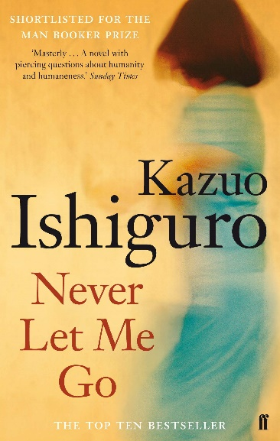
Never Let Me Go takes place in a dystopian version of late 1990s England, where the lives of ordinary citizens are prolonged through a state-sanctioned program of human cloning. The clones, referred to as students, grow up in special institutions away from the outside world. As young adults, they begin to donate their vital organs.
“Boys, you must forgive me for listening. But you were right behind me, so I couldn't help it. Peter, why don't you tell the others what you were saying to Gordon just now?”
Peter J. looked bewildered and I could see him getting ready his injured innocence face. But then Miss Lucy said again, this time much more gently:
“Peter, go on. Please tell the others what you were just saying.”
Peter shrugged. “We were just talking about what it would feel like if we became actors. What sort of life it would be.”
“Yes,” Miss Lucy said, “and you were saying to Gordon you'd have to go to America to stand the best chance.”
Peter J. shrugged again and muttered quietly: “Yes, Miss Lucy.”
But Miss Lucy was now moving her gaze over the lot of us. “I know you don't mean any harm. But there's just too much talk like this. I hear it all the time, it's been allowed to go on, and it's not right.” I could see more drops coming off the gutter and landing on her shoulder, but she didn't seem to notice. “If no one else will talk to you,” she continued, “then I will. The problem, as I see it, is that you've been told and not told. You've been told, but none of you really understand, and I dare say, some people are quite happy to leave it that way. But I'm not. If you're going to have decent lives, then you've got to know and know properly. None of you will go to America, none of you will be film stars. And none of you will be working in supermarkets as I heard some of you planning the other day. Your lives are set out for you. You'll become adults, then before you're old, before you're even middle-aged, you'll start to donate your vital organs. That's what each of you was created to do. You're not like the actors you watch on your videos, you're not even like me. You were brought into this world for a purpose, and your futures, all of them, have been decided. So you're not to talk that way any more. You'll be leaving Hailsham before long, and it's not so far off, the day you'll be preparing for your first donations. You need to remember that. If you're to have decent lives, you have to know who you are and what lies ahead of you, every one of you.”
Then she went silent, but my impression was that she was continuing to say things inside her head, because for some time her gaze kept roving over us, going from face to face just as if she were still speaking to us. We were all pretty relieved when she turned to look out over the playing field again.
“It's not so bad now,” she said, even though the rain was as steady as ever. “Let's just go out there. Then maybe the sun will come out too.”
So I'd say Miss Lucy had it about right when she said, a couple of years later, that we'd been “told and not told.” And what's more, now I think about it, I'd say what Miss Lucy said to us that afternoon led to a real shift in our attitudes. It was after that day, jokes about donations faded away, and we started to think properly about things. If anything, the donations went back to being a subject to be avoided, but not in the way it had been when we were younger. This time round it wasn't awkward or embarrassing any more; just sombre and serious.
“It's funny,” Tommy said to me when we were remembering it all again a few years ago. “None of us stopped to think about how she felt, Miss Lucy herself. We never worried if she'd got into trouble, saying what she did to us. We were so selfish back then.”
“But you can't blame us,” I said. “We'd been taught to think about each other, but never about the guardians. The idea the guardians had differences between them, that never occurred to us.”
“But we were old enough,” Tommy said. “By that age, it should have occurred to us. But it didn't. We didn't think about poor Miss Lucy at all. Not even after that time, you know, when you saw her.”
I knew straight away what he meant. He was talking about the morning early in our last summer at Hailsham, when I'd stumbled across her up in Room 22. Thinking about it now, I'd say Tommy had a point. After that moment it should have been clear, even to us, how troubled Miss Lucy had become. But as he said, we never considered anything from her viewpoint, and it never occurred to us to say or do anything to support her.

A Clockwork Orange
In the dystopian world of A Clockwork Orange, language has changed. The words that we use now are replaced by other words that Anthony Burgess makes up.
The made-up words are bolded and underlined in your copy. Use the rest of the sentence that the word is in to work out what it might mean. For example, ‘droogs’ could mean ‘friends’ or ‘colleagues’.

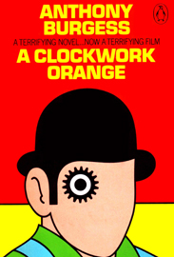
There was me, that is Alex, and my three droogs, that is Pete, Georgie, and Dim, Dim being really dim, and we sat in the Korova Milkbar making up our rassoodocks what to do with the evening, a flip dark chill winter though dry. The Korova Milkbar was a milk-plus mesto, and you may, O my brothers, have forgotten what these mestos were like, things changing so skorry these days and everybody very quick to forget, newspapers not being read much neither. Well, what they sold there was milk plus something else. They had no licence for selling liquor, but there was no law yet against prodding some of the new veshches which they used to put into the old moloko, so you could peet it with vellocet or synthemesc or drencrom or one or two other veshches which would give you a nice quiet horrorshow fifteen minutes admiring Bog And All His Holy Angels and Saints in your left shoe with lights bursting all over your mozg. Or you could peet milk with knives in it, as we used to say, and this would sharpen you up and make you ready for a bit of dirty twenty-to-one, and that was what we were peeting this evening I'm starting off the story with.
Our pockets were full of deng, so there was no real need from the point of view of crasting any more pretty polly to tolchock some old veck in an alley and viddy him swim in his blood while we counted the takings and divided by four, nor to do the ultra-violent on some shivering starry grey-haired ptitsa in a shop and go smecking off with the till's guts. But, as they say, money isn't everything.
The four of us were dressed in the height of fashion, which in those days was a pair of black very tight tights with the old jelly mould, as we called it, fitting on the crotch underneath the tights, this being to protect and also a sort of a design you could viddy clear enough in a certain light, so that I had one in the shape of a spider. Pete had a rooker (a hand, that is), Georgie had a very fancy one of a flower, and poor old Dim had a very hound-and-horny one of a clown's litso (face, that is). Dim not ever having much of an idea of things and being, beyond all shadow of a doubting thomas, the dimmest of we four. Then we wore waisty jackets without lapels but with these very big built-up shoulders ('pletchoes' we called them) which were a kind of a mockery of having real shoulders like that. Then, my brothers,

we had these off-white cravats which looked like whipped-up kartoffel or spud with a sort of a design made on it with a fork. We wore our hair not too long and we had flip horrorshow boots for kicking.
'What's it going to be then, eh?'
There were three devotchkas sitting at the counter all together, but there were four of us malchicks and it was usually like one for all and all for one. These sharps were dressed in the height of fashion too, with purple and green and orange wigs on their gullivers, each one not costing less than three or four weeks of those sharps' wages, I should reckon, and make-up to match (rainbows round the glazzies, that is, and the rot painted very wide). Then they had long black very straight dresses, and on the groody part of them they had little badges of like silver with different malchicks' names on them – Joe and Mike and suchlike. These were supposed to be the names of the different malchicks they'd spatted with before they were fourteen. They kept looking our way and I nearly felt like saying the three of us (out of the corner of my rot, that is) should go off for a bit of pol and leave poor old Dim behind, because it would be just a matter of kupetting Dim a demi-litre of white but this time with a dollop of synthemesc in it, but that wouldn't really have been playing like the game. Dim was very very ugly and like his name, but he was a horrorshow filthy fighter and very handy with the boot.

Fahrenheit 451

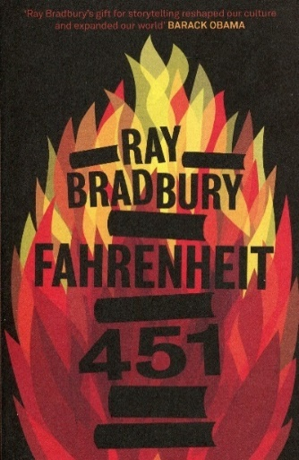
This extract is from the opening of a novel by Ray Bradbury. Published in 1953, the novel is set in the future. In this section Guy Montag is a fireman who is in charge of the burning of books.
As we read, consider how the narrator feels about burning the books?
How do we feel towards the narrator? Is he a hero, a villain, somewhere in between?
Farenheit 451
It was a pleasure to burn. It was a special pleasure to see things eaten, to see things blackened and changed. With the brass nozzle in his fists, with this great python spitting its venomous kerosene upon the world, the blood pounded in his head, and his hands were the hands of some amazing conductor playing all the symphonies of blazing and burning to bring down the tatters and charcoal ruins of history. With his symbolic helmet numbered 451 on his stolid head, and his eyes all orange flame with the thought of what came next, he flicked the igniter and the house jumped up in a gorging fire that burned the evening sky red and yellow and black. He strode in a swarm of fireflies. He wanted above all, like the old joke, to shove a marshmallow on a stick in the furnace, while the flapping pigeon-winged books died on the porch and lawn of the house. While the books went up in sparkling whirls and blew away on a wind turned dark with burning.
Montag grinned the fierce grin of all men singed and driven back by flame.
He knew that when he returned to the firehouse, he might wink at himself, a minstrel man, burntcorked, in the mirror. Later, going to sleep, he would feel the fiery smile still gripped by his face muscles, in the dark. It never went away, that smile, it never ever went away, as long as he remembered.
He hung up his black-beetle-coloured helmet and shined it, he hung his flameproof jacket neatly; he showered luxuriously, and then, whistling, hands in pockets, walked across the upper floor of the fire station and fell down the hole. At the last moment, when disaster seemed positive, he pulled his hands from his pockets and broke his fall by grasping the golden pole. He slid to a squeaking halt, the heels one inch from the concrete floor downstairs.
He walked out of the fire station and along the midnight street toward the subway where the silent, air-propelled train slid soundlessly down its lubricated flue in the earth and let him out with a great puff of warm air and on to the cream-tiled escalator rising to the suburb.
Whistling, he let the escalator waft him into the still night air. He walked toward the corner, thinking little at all about nothing in particular. Before he reached the corner, however, he slowed as if a wind had sprung up from nowhere, as if someone had called his name. The last few nights he had had the most uncertain feelings about the sidewalk just around the corner here, moving in the starlight toward his house. He had felt that a moment before his making the turn, someone had been there. The air seemed charged with a special calm as if someone had waited there, quietly, and only a moment before he came, simply turned to a shadow and let him through. Perhaps his nose detected a faint perfume, perhaps the skin on the backs of his hands, on his face, felt the temperature rise at this one spot where a person's standing might raise the immediate atmosphere ten degrees for an instant. There was no understanding it. Each time he made the turn, he saw only the white, unused, buckling sidewalk, with perhaps, on one night, something vanishing swiftly across a lawn before he could focus his eyes or speak.

