The disappearing spoon by Sam Kean
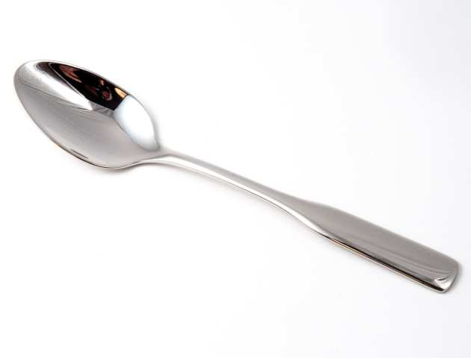
I recommend this book for anyone with an interest in chemistry. The author takes you on a tour of the periodic table, showcasing how a variety of elements from the notorious to the obscure have driven advancements in chemistry. The author places an emphasis on how these advancements in chemistry have impacted health, politics, economics, war and technology – and how it has not always, knowingly or unknowingly, been used for good. A focus on the societal impact of chemistry is effectively used as a vehicle to introduce higher-level concepts in chemistry that reach beyond the syllabus. The main reason that I really love this book and come back to it time and time again is the way that key scientific figures are really brought to life. Kean paints a full and thoroughly unvarnished picture of famous people like Marie Curie and really makes them feel human, rather than the abstract, one-dimensional characters they are often portrayed as. It’s certainly not a textbook, but I think it does a good job of introducing the breadth of chemistry.

Uncle Tungsten – memories of a chemical boyhood by Oliver Sacks
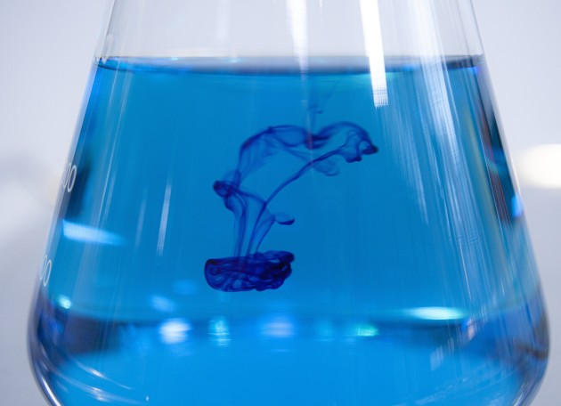
Suggested by Daniel Glass, Research Postgraduate Physics
An autobiography like you’ve never seen it. Coming from a large very scientific family Oliver Sacks walks you through his life in chemistry, from a child’s fascination of science and nature to his early career days. Aside from seeing a whole range of elements and compounds in a light you never thought was possible, Sacks presents a history of chemistry and science through his journey of discovery. Although the book focuses primarily on Sacks’s chemistry adventures the book appeals to all, from the young budding scientist to a renown professor. As you turn through the pages you get to join the experiments, excitement and the memories of a chemical boyhood during war time Briton. The book portrays an admiral raw passion and excitement for the thrill and discovery of science.

Periodic tales: The curious lives of the elements by Hugh Aldersey-Williams
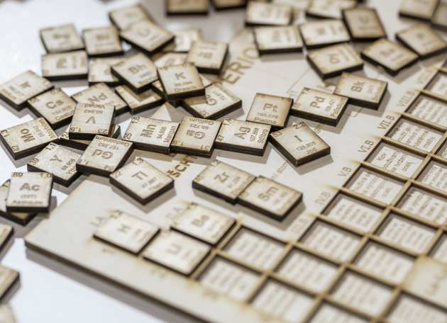
Suggested by Dr Mel Bottrill, Deputy Head of Outreach
As a complete nerd about the periodic table, I love this book because it showcases the human stories behind the elements. The periodic table is something that I found intimidating as a school student, but as I studied chemistry at A-Level I began to love and to realise how beautiful I found it. We often see it as a tool, concentrating on its properties and patterns, but it is so much more and this book demonstrates how much more it is. It is a tour of discovery, outlining the stories of the different discoveries of the elements, the people that discovered them and interesting and funny facts about how they are used – almost a travelogue of the elements. You don’t have to be studying chemistry to find something enjoyable about this book!

