

EMERSON PARK ACADEMY
MUSIC EXTRA-CURRICULAR TIMETABLE
 | MONDAY | TUESDAY | WEDNESDAY | THURSDAY | FRIDAY
Lunch |   Ukulele Club | Jazz Band   | Singers   | Concert Band  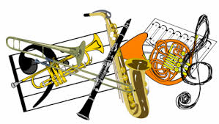 | GCSE Music  Coursework  Clinic  

- Music practice rooms are available at break times and some lunch times. Please ask Mr Wing or Mr Cuthbert if you would like to use a practice room.

