Term Time - Revision Timetable
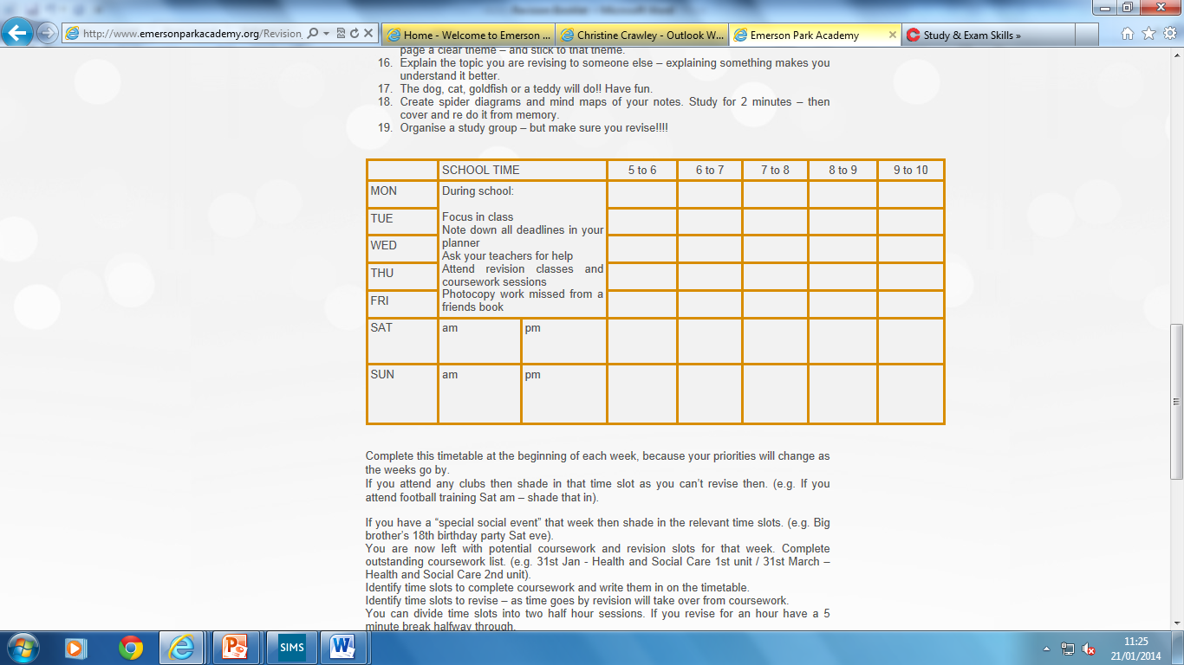

Allocate time to study and time to relax. | Monday | Tuesday | Wednesday | Thursday | Friday | Saturday | Sunday
Morning
Afternoon
Evening
Holiday Time – Revision Timetable

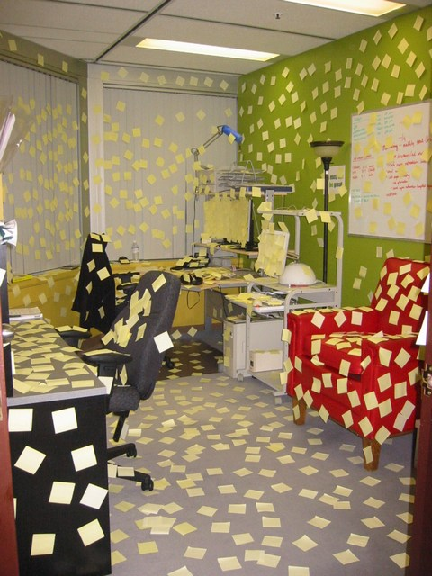
1. Post it notes – stick them all over the house in places you
often walk past.

2. Highlight important information – on the post it notes,
on your extended notes from school - everything stands out
better if you highlight it.

3. Make your notes colourful and neat. This is the same
principle as the highlighting - colour makes things stand out and
if the notes are neat they will be much easier to quickly work
through.

4. Make quizzes and questions for friends – use text
messaging, e-mail, even paper and a pen.

5. Take breaks – if you concentrate for too long you switch off
and won’t learn anything so only revise for short but intense
periods.

6. Give yourself rewards – you should have something to
look forward to, whether it is food or a television programme. This will also give you a time limit for revision so you won’t get too bored.

7. Use all available resources – the Internet, library,
revision guides, friends notes, class notes, there are a variety of
places to gather information and you should take full advantage
of this.

8. Revision timetable – use it!

Revise with a friend and test each other. Or take a topic each and explain it to each other.
Do not just read – you will fall asleep!!!!!!!!

Shopping list for revision
Highlighter pens
Small notebooks
Plain A4 paper
Make sure you are clear about what topics will come up on which exams.
Use a textbook to help you make notes and also help you catch up on any work that you have missed.

Condense your notes
Read your notes – using a highlighter pen to highlight the words that you feel are important.

Then using a small notepad – make notes from your notes. Make sure you give each page a clear theme – and stick to that theme.
Create spider diagrams and mind maps of your notes. Study for 2 minutes – then cover and re do it from memory.
Explain the topic you are revising to someone else – explaining something makes you understand it better.
The dog, cat, goldfish or a teddy will do!! Have fun.

Organise a study group – but make sure you revise!!!!
Make a revision timetable and stick to it.

Make sure you have a comfortable place to revise in!
Remember to ask your teacher for help if you do not understand something.
If you have missed any work then photocopy a friend’s book.

