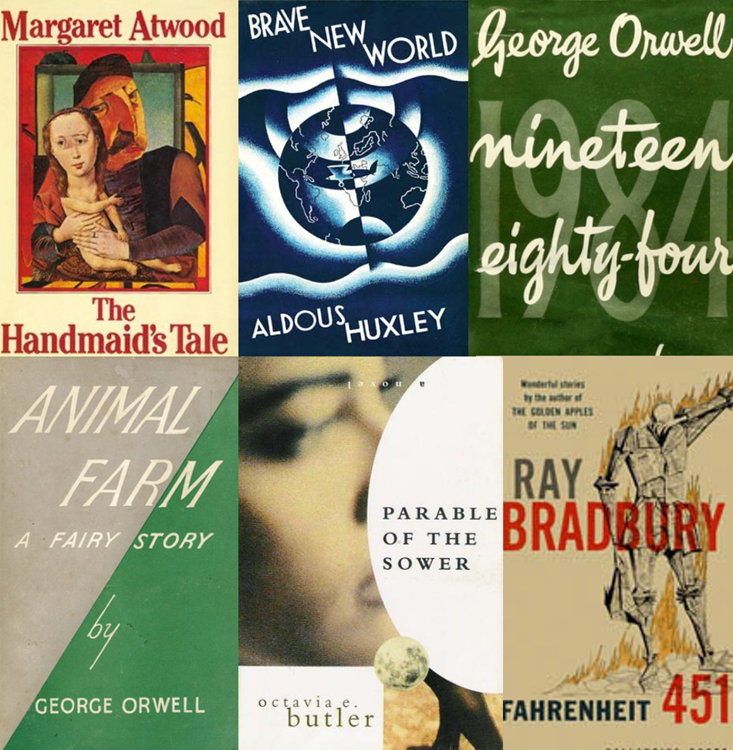

‘The trouble with having an open mind, of course, is that people will insist on coming along and trying to put things in it.’

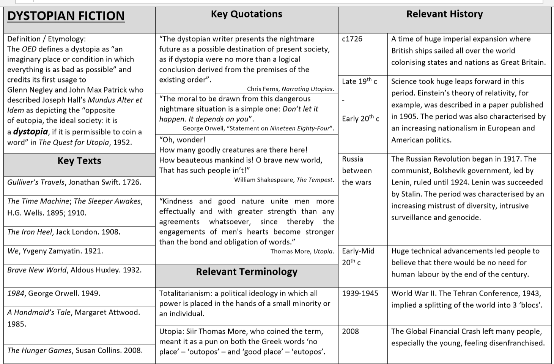
Think about these ‘big’ questions. What are your pre-conceptions of ‘dystopia’?
Big questions
What are the conventions of dystopian fiction?
Why do we love reading dystopian fiction?

How do we envision a dystopian future?
How do writers use character and language to convey government control?
How is environmental destruction used in dystopian fiction?
How is technological control used in dystopian fiction?
How do writers use structure and character to convey the theme of survival?
How do writers use language and character to convey a loss of individualism?

Key vocabulary
Dystopia  from the C18th dys ‘bad’ + utopia ‘no place’. | An imagined state or society in which there is great suffering or injustice, typically one that is totalitarian or post-apocalyptic.
Allusion  from French, or from late Latin allusio(n- ), from the verb alludere. | An expression or phrase that refers to a well-known story or idea without naming it explicitly.
Protagonist  from Greek prōtagōnistēs, from prōtos ‘first in importance’ + agōnistēs ‘actor’. | The leading or major character in a play, film, novel etc.
Archetypal  from Greek arkhetupon ‘something moulded first as a model’. | Typical of a certain person or thing.
Conformity  from Old French conformer, from Latin conformare, from con- ‘together’ + formare ‘to form’. | Compliance with standards, rules or laws. Behaving or acting in an accepted way to fit in with others.
Dissimulate  from Latin dissimulat- ‘hidden, concealed’, from the verb dissimulare. | Conceal or disguise (one’s thoughts, feelings or character).
Monolithic  from Latin monolithus ‘consisting of a single stone’. | To call a group of people monolithic: implies they are all alike and act as one.  To call a society monolithic: closed off from others, indivisible and unlikely to change.
Impose  from Latin imponere ‘inflict, deceive’ (from in- ‘in, upon’ + ponere ‘put’), but influenced by impositus ‘inflicted’. | To force (an unwelcome decision or ruling) on someone.
Surveillance  from French, from sur- ‘over’ + veiller ‘watch’ (from Latin vigilare ‘keep watch’). | Close observation, especially of a suspected spy or criminal.
Scapegoat  from mid C16th archaic scape ‘escape’ + goat ‘alluding to the bible: a goat was sent into the wild after a priest had laid the sins of the people upon it’. | A person who is blamed for the mistakes, or faults, of others.
Dictatorship  from Latin, from dictat- ‘dictated’, from the verb dictare. | A society with a ruler who has total power over everything and everyone – typically by force.
Tyranny  from late Latin tyrannia ‘rule of a tyrant’ – a tyrant being a cruel master. | Cruel, unreasonably and oppressive use of power or control.
Allegory  from Greek allēgoria, from allos ‘other’ + -agoria ‘speaking’. | A narrative that contains a hidden meaning, typically a moral or political one.
Satire  from Latin satira, and satura ‘poetic medley’. | The use of humour, exaggeration, ridicule or irony to expose and criticise stupidity – usually political or topical issues.
Totalitarianism  from Italian totalitario – not allowing others’ views. | A government that requires complete subservience.

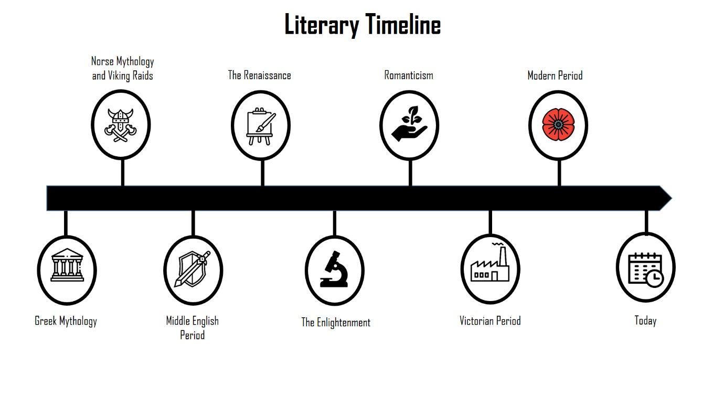

What is dystopian fiction?
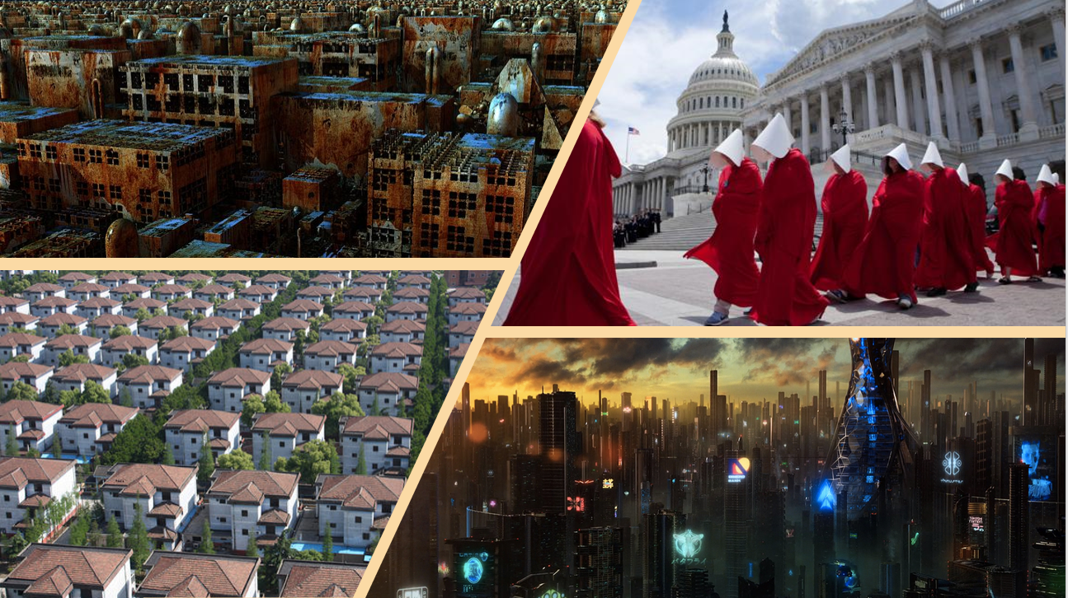
All of these images show you what a dystopia might look like. In a mind-map, generate your ideas of what a dystopian world might be.

What is dystopian fiction?
Dystopian fiction offers a vision of the future. Dystopias are societies in cataclysmic decline, with characters who battle environmental ruin, technological control, and government oppression. Dystopian novels can challenge readers to think differently about current social and political climates, and in some instances can even inspire action.
What Is Dystopian Fiction?
Dystopian literature is a form of speculative fiction that began as a response to utopian literature. A dystopia is an imagined community or society that is dehumanizing and frightening. A dystopia is an antonym of a utopia, which is a perfect society.

Dystopian novels that have a didactic message often explore themes like anarchism, oppression, and mass poverty. Margaret Atwood, one of literature’s most celebrated authors of dystopian fiction, thinks about it like this:
“If you’re interested in writing speculative fiction, one way to generate a plot is to take an idea from current society and move it a little further down the road. Even if humans are short-term thinkers, fiction can anticipate and extrapolate into multiple versions of the future.”
Think pair share: What could this quote mean? What does it hint that dystopian fiction might be like?

  Dystopian fiction can be a way to educate and warn humanity about the dangers of current social and political structures. Margaret Atwood’s 1985 novel The Handmaid’s Tale takes place in a futuristic United States, known as Gilead. It cautions against oppressive patriarchy. |   Dystopian stories may convey an author’s beliefs. For example, H.G. Wells’ 1895 novel The Time Machine reflected Wells’ socialist views. The story follows a Victorian England scientist who builds a time machine and witnesses the pitfalls of a capitalist society.
  Dystopian stories require a greater suspension of disbelief and can be very imaginative. For example, George Orwell’s allegory Animal Farm is about a group of pigs who stage a rebellion against their human farmer. The farm animals’ rise to power is based on the Russian Revolution. |   Dystopian novels can also be satirical critiques. For example, the 1962 novel A Clockwork Orange by Anthony Burgess is a social satire of behaviourism. It takes place in a futuristic society with a youth subculture of extreme violence. A totalitarian government protects society by prescribing good behaviour and abolishing violent impulses.
BQ: Why do we love reading dystopian fiction?
Someone Might Be Watching — An Introduction to Dystopian Fiction By Shelby Ostergaard, 2017
Walking through carnivals, we love to laugh at the versions of ourselves that appear in the funhouse mirror. We delight in taking selfies with filters that artificially bulge out our noses or shrink our mouths. But sometimes these distortions take on a deeper meaning and force us to notice things about ourselves. You don’t notice that your nose is a little large until you take a picture with that filter and compare. The version of yourself in the mirror shows you things about yourself. Dystopias are usually constructed through this type of magnification. Authors take troubling aspects of their own society and imagine a world where they are taken to the extreme. Because of how they are constructed, dystopias are often seen as a desperate warning sign. The truth is, dystopian fiction presents a funhouse mirror of our collective selves. It forces the audience to stare, transfixed, at the small flaws which, in the mirror, have become pronounced enough to produce a monster.
History of dystopias
The term dystopia stems from another word: utopia. The English word utopia comes from the Greek “ou-” (οὐ) meaning “not” and “topos” (τόπος) meaning “place.” It translates literally to ‘no place’, or nowhere. Thomas More coined the term in 1516 when he published a book that described a perfect fictional island society. He titled the book Utopia to emphasize that he was describing a made-up place that he considered perfect. The perfection that More, and other philosophers who wrote about utopias, imagined was never intended to be real. Philosophers from More to Plato understood that the perfection they wrote about did not exist in reality, it was ‘no place.’
If you think of dystopian literature as holding up a funhouse mirror to society, you can also think of utopian literature as retouching a photo of society. The overly perfected image is less concerned with reality than with showing us an unobtainable perfection.
If you think of dystopian literature as holding up a funhouse mirror to society, you can also think of utopian literature as retouching a photo of society. The overly perfected image is less concerned with reality than with showing us an unobtainable perfection.
But, by the 1900s, for the first time in human history, perfection like that seemed possible for society. Technological advances had spurred on the industrial revolution. Philosophers and politicians saw this automation and, for the first time, a vision of a world without difficult, toiling, physical labour seemed not only possible, but likely. Economic theories envisioned a world without staggering class inequality or crippling poverty. At the turn of the century, the predominant view was that humanity constantly progressed. History was seen as one long forward march that would lead, inevitably, to perfection. However, throughout the 1900s, no matter how much humanity progressed, perfection was never achieved. The promises of technology and sociopolitical theory only resulted in war, poverty, famine, and chaos.
As the century progressed, authors began to question the idea that societies should be attempting perfection at all by writing dystopian fiction. Dystopia stems from two Greek words that translate to ‘bad place.’ It describes a fictional setting that the author finds horrifying. But, unlike other genres, dystopias prod the audience into examining contemporary political and social structures. Dystopian authors argued that the pursuit of perfection will inevitably lead not to ‘no place’ but to a ‘bad place’, because of flaws within the system. And they made it their business to use fiction to hold up funhouse mirrors to magnify those flaws and force discussion about them.
distortions | transfixed | sociopolitical

Question: How is environmental destruction used in dystopian fiction?
Dystopian novels are often set in places that are inhabitable, have been destroyed, or are preparing for destruction.
These images are taken from the film version of the book we will be studying an extract from today. It is called ‘The Road’.
Make three assumptions about what has happened in their dystopian world.
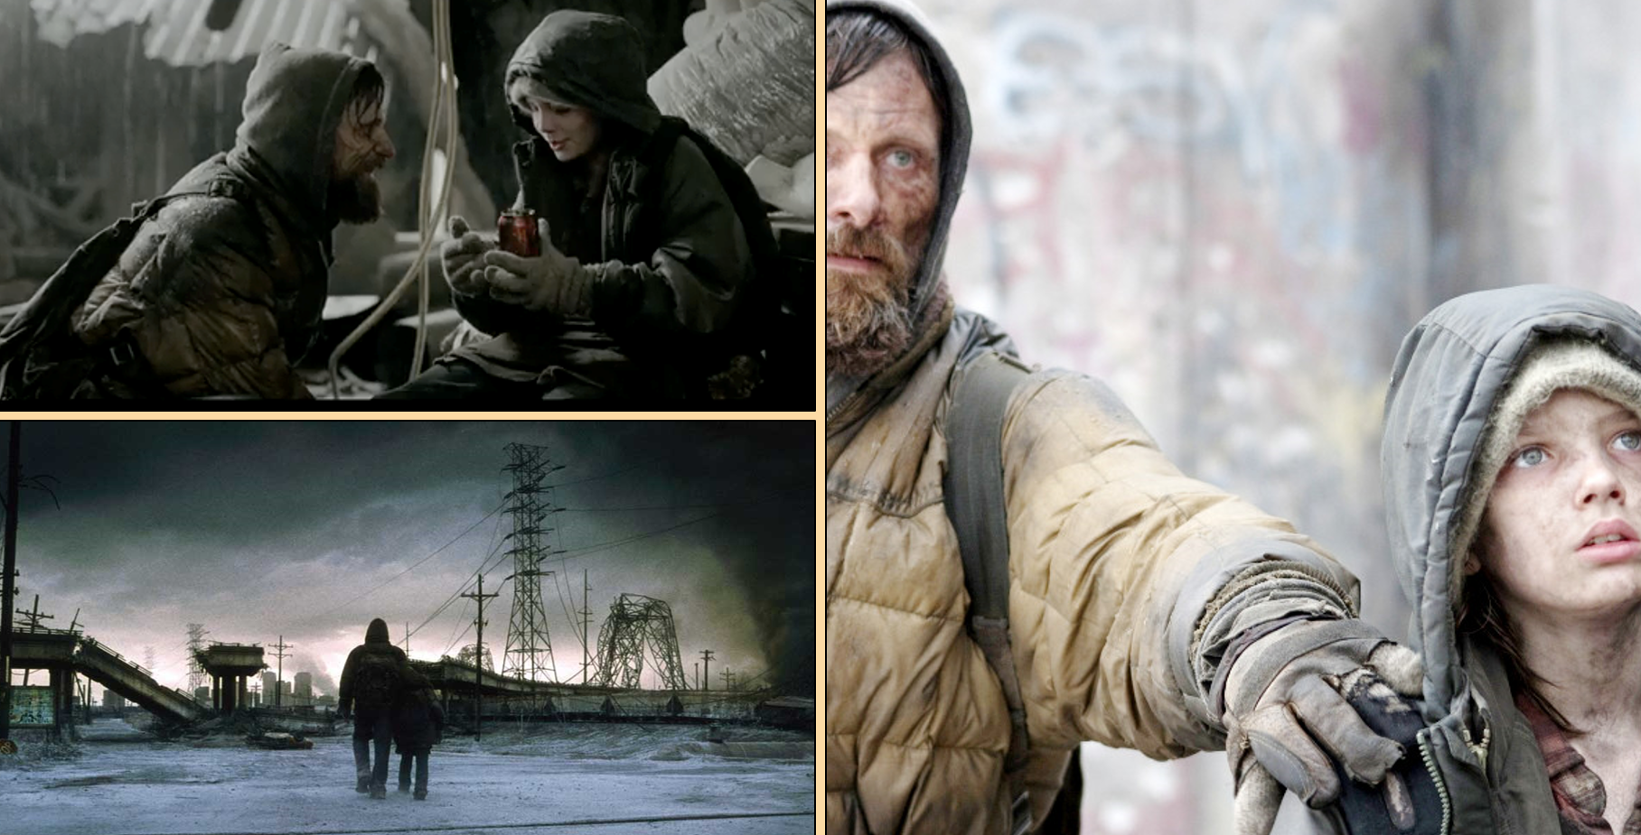
1.__________________________________________________________________________
2.__________________________________________________________________________
3.__________________________________________________________________________

