Why evolution is true by Jerry Coyne
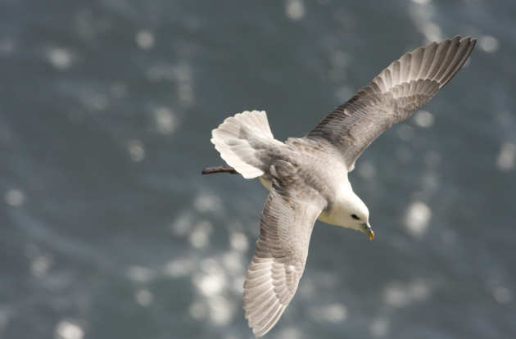
I read "Why Evolution is True" for the first time after I decided to study biology at university. I loved the way Coyne weaves together different fields, including genetics, molecular biology and anatomy, with colourful and interesting examples from across the living world. Everything is linked in a clear and accessible way to the central argument - Coyne takes a true scientist's approach as he tours the evidence and examines the details. Reading this book, I began to understand how evolution is the golden thread tying together all of the fields of biology - it changed my perspective on the natural world. If you're interested in studying biology, or understanding evolution, I would thoroughly recommend picking up this book!

The blind watchmaker by Richard Dawkins
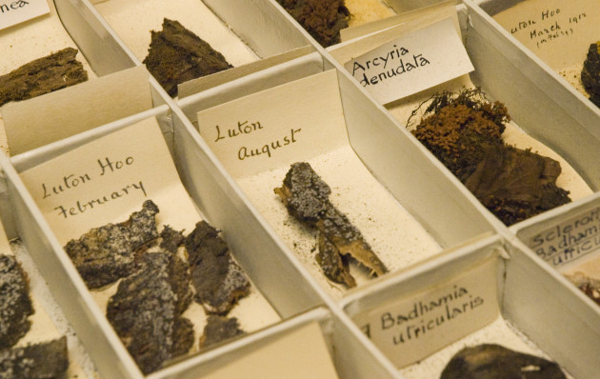
The Blind Watchmaker explores the theory of evolution and was published after Dawkin's most well- known book, The Selfish Gene (where the term meme is first used!). I read it when I was studying A levels and found it really clear and easy to read. I loved reading a book about science that contained lots of scientific facts and information but also used examples and eloquent writing to form persuasive arguments. The simple descriptions taught at school around natural selection make sense but when you look at the world and the amazing complexity of living creatures it does sometimes seem impossible that this could happen by chance - this book gives you confidence that this could happen! I have read a few of Dawkin's later books which I found a little too strong in their anti-creationist arguments but this book balances this well.

The omnivore’s dilemma: A natural history of four meals by Michael Pollan
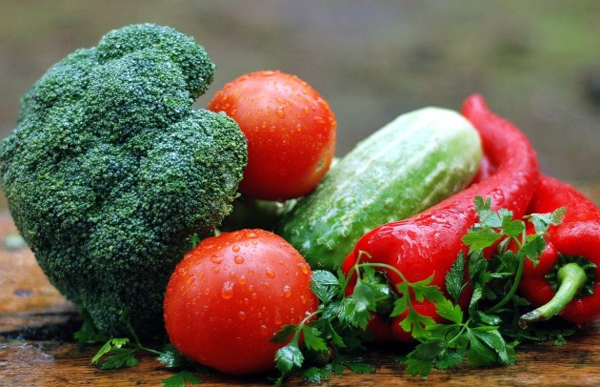
Suggested by Joanna L Clasen, Research Postgraduate School of Public Health
As a fan of cooking, and food in general, I found this book to be a fascinating read. It cuts across disciplines and shows the interwoven complexity of how science, economics, and culture influence our diets. The author takes a seemingly ordinary topic and turns it into an interesting and easy read. I am a student working in nutritional epidemiology, and I love books that provide a different perspective on food and nutrition.

The private life of plants by David Attenborough
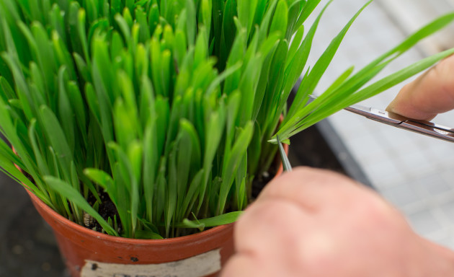
I’ve always been fascinated by plants ever since I was very young when someone gave me a Venus Fly Trap. Watching it catch flies (and perhaps over triggering it with a little prod here and there) made me want to know why it did it and what it did with the fly once its ‘jaws’ had closed. I watched the TV series that accompanied this book many years ago and I was amazed at just how incredible plants truly are. The book takes you through every part of a plant’s life cycle, using examples, stunning photography and astounding facts. If you think that they are just boring green things that grow, make flowers, look nice and get us out of a trouble when we’ve forgotten a birthday, think again…. You’ll learn just how sophisticated some are, how they can replicate insect pheromones or produce ultra violet light to attract the right pollinators, aggressively stop other plants encroaching on their space and actually repel other organisms with a hideous stench. I challenge you NOT to be amazed by just how highly evolved some plants are. You’ll never look at an orchid in the same light…. Literally…

