Brave new world by Aldous Huxley
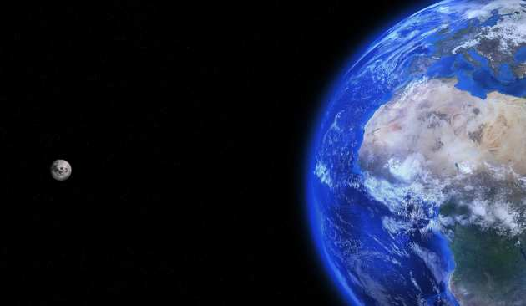
Suggested by Helen Sharman, UK Outreach Ambassador
Set in a futuristic social and political world, although written way back in 1931, this book made me think about how society uses science, in particular that the same knowledge can be used for good or bad purposes. It is amazingly inciteful, given that it was written way before IVF was developed and before we knew what we do about foetal development, yet it provokes thought about genetic engineering and other ways we change and adapt as humans. I really liked the way the main character held opinions based on logic that were against what everyone else had been made to think. For me, science wins over unthinking conditioning any day!

The man who mistook his wife for a hat by Oliver Sacks
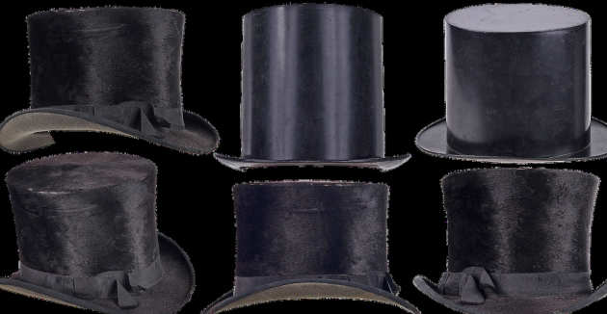
Suggested by Rebecca Sweeney, Reach Out Makerspace Assistant
A fascinating look into the curious and bewildering effects when something in the brain goes wrong. Neurologist Oliver Sacks shares a collection of case histories of patients he has treated for bizarre neurological disorders, recounting extraordinary tales of profound amnesias, photographic memory, ‘seeing’ musical sounds, phantom limbs, and a man whose visual agnosia meant he perceived his wife as a hat. I love this book because it poignantly illustrates both the fragility of our 1.5kg brain and its remarkable ability to compensate for cognitive deficiencies, often with comical yet wondrous consequences.

The ghost map by Steven Berlin Johnson
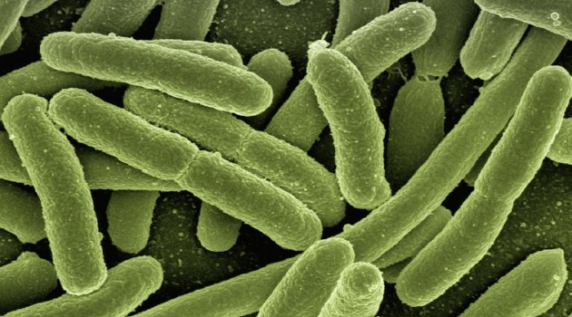
Suggested by Ahreum Jung, Invention Room Associate: Hacking and Making
The Ghost Map: The story of London's most terrifying epidemic – and how it changed science, cities and the modern world is a book by Steven Berlin Johnson in which he describes the most intense outbreak of cholera in Victorian London and centers on John Snow and Henry Whitehead.

Happy accidents: Serendipity in modern medical breakthroughs by Morton A. Meyers

Suggested by Elzbieta Lauzikaite, Research Postgraduate Dept of Metabolism, Digestion and Reproduction
An highly entertaining book on the role of serendipity in medical research, covering the most important discoveries in the 20th century. It reminded me of the importance of an open and creative mind, and that not everything in science goes according to a plan.

