The quantum universe: Everything that can happen does happen” by Jeff Forshaw and Brian Cox
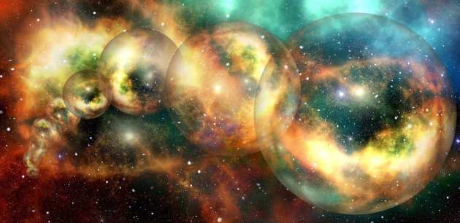
Suggested by Joe Sykes, Research Postgraduate Mathematics
This was the book that opened my eyes to the strange quantum aspect of physics (something that is hardly ever touched on in A level physics but underpins all of physics) and ultimately made up my mind that I needed to go to university and do physics because I needed to understand how this weird (and in my nerdy opinion very cool) quantum stuff worked. The book is very accessible as it is written for the general public and isn’t too mathematical and is very good at intriguing the reader to want to find out more.

The perfect theory: A century of geniuses and the battle over general relativity by Pedro G. Ferreira
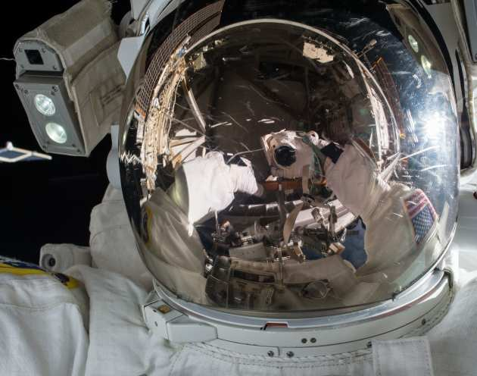
Suggested by Renee Boling, STEM Programmes Coordinator Pre-16
As an aerospace engineer I have always been fascinated by space and the role of gravity in the universe. When Einstein published his theory of general relativity in 1915 little did he know where it would take us. This book is the biography not of a person, but an idea. It follows the life of the theory through the brilliant physicists, mathematicians and astronomers who studied, challenged and expanded our knowledge of the universe with this theory from black holes to the quantum discoveries happening at the Large Hadron Collider today. Written for those with no science or mathematical backgrounds it is a fun and enjoyable read about the life and impact of a scientific theory.

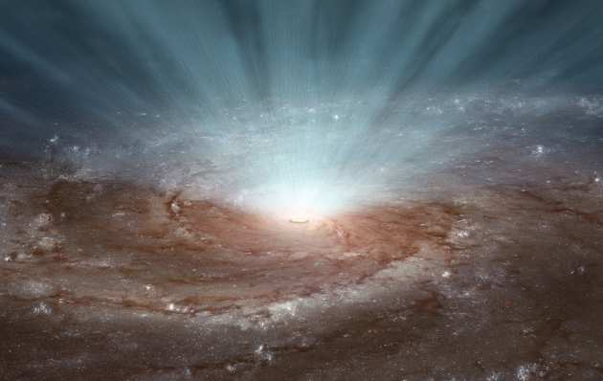
Reality is not what it seems by Carlo Rovelli
Suggested by Scott Marley, Outreach Leader
This book is about the current work towards combining quantum mechanics and general relativity – a topic that many scientists would struggle with to make readable! Instead, Rovelli writes more like an author crafting a novel than a scientist trawling the depths of theoretical physics and has produced the most readable guide I’ve seen to this complex and fascinating topic. If you like this book, I can also recommend ‘The order of time’ and ‘Seven brief lessons on physics’ both by Rovelli.

The particle at the end of the universe by Sean Carroll
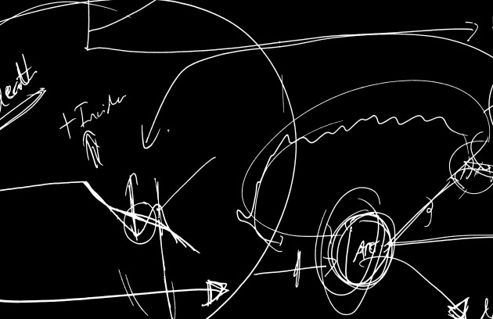
Suggested by Scott Marley, Outreach Leader
Fast-moving, fascinating and oftentimes quite funny, this book beautifully covers the search for and discovery of the Higgs Boson. Carroll explains how we should think of the Universe in terms of fields rather than particles, and how symmetries and symmetry breaking set out the rules that govern the cosmos. When I first read this, I did so in two days, then had to read it again a few weeks later to cover all the things I had missed the first time!

Longitude by Dava Sobel

Suggested by José Monteiro, STEM Potential Coordinator
Something I have always enjoyed is looking at maps and planning road trips by bike or car. It is difficult to get lost now we can all carry phones with GPS receivers in our pockets. Until the 18th century, many lives were lost at sea as there was not a reliable way to know a ship’s exact location. This book tells the story of the quest to solve this problem. It focuses on the life of John Harrison who worked all his life to accomplish this. You read it just like you would read a novel following Harrison’s achievements and setbacks trying to convince others that his ideas would work. More than presenting scientific knowledge, this book shows a thrilling example of personal work done when solving scientific and technical problems. It may even get some people interested in navigation and clock making!

Quantum by Manjit Kumar
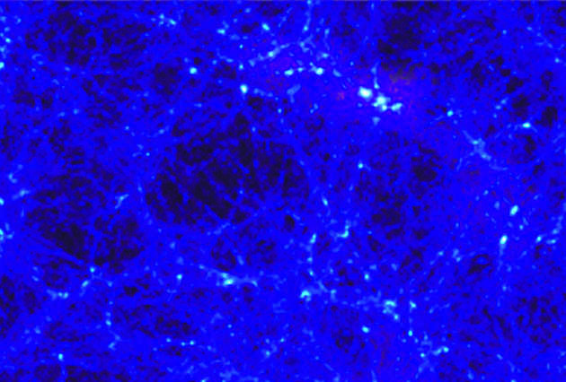
Suggested by Scott Marley, Outreach Leader
Although it covers the basic science of quantum mechanics, this book is really about the incredible characters involved in the theory’s development. Focussing on the great rivalry between Einstein and Bohr, this roller-coaster of a book follows a wide cast of characters as they try to determine the true nature of reality. It reminds us that science is carried out by real people, with all the drama and emotion that entails.

