Parenting Drop-in
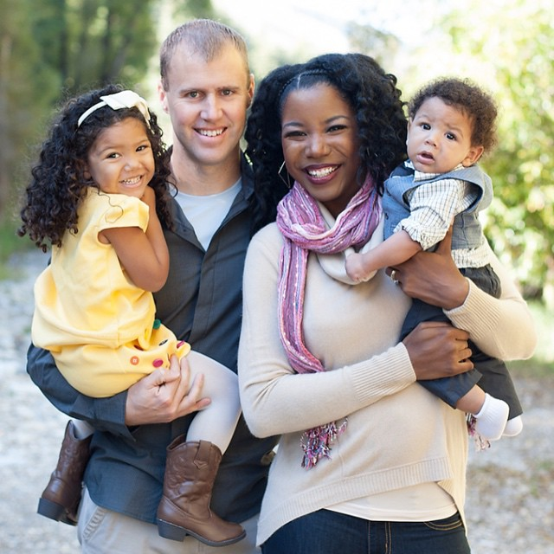

New rolling 6 week programme for parents and carers to drop in and receive advice around the following topics:

- Positive Role-Models/Quality Time
- Communication/Active Listening
- Praise
- Identifying and Prioritising Problematic Behaviours
- De-escalation
- Self-Care

Contact us to find out more
and join the programme
t| 01708 432 636
e| parenting@havering.gov.uk
Two sessions each week are available to join:
Mondays 9.30-11.00am at St Kilda Children’s Centre
Tuesdays 6.00pm- 7.30pm virtually via Microsoft Teams

Join on your computer or mobile app
Click here to join the meeting

