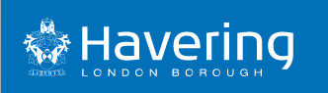

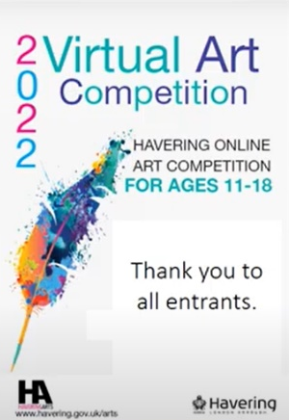

Havering Arts Competition
Students from Emerson Park Academy entered the Havering Arts competition run by Havering Borough Council. You can view their work on the following link or below:-

https://youtu.be/5I0hZukq_h8

Jamie-Leigh – Year 8
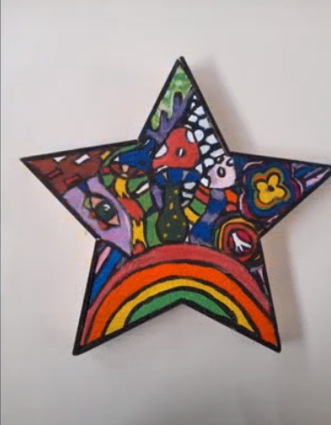
Kabir – Year 10
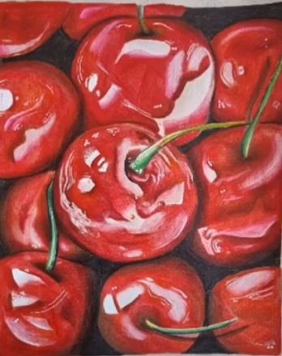
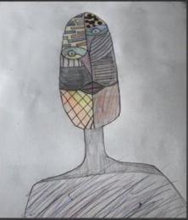
Engjell – Year 9

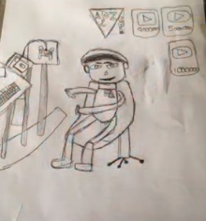
Adam – Year 8

Samuel – Year 8
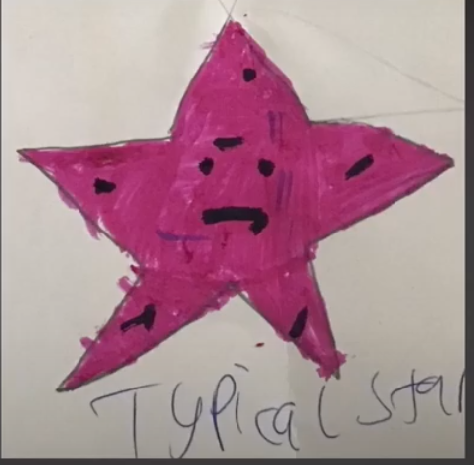
You can view the overall winner Kabir on the following link.
https://youtu.be/fhGE_9ZrgNc

