Havering Adult College free family learning
01708 434955
enquiries-adultcollege@havering.gov.uk

https://haveringadultcollege.co.uk/product/supporting-families-with-emotional-wellbeing/
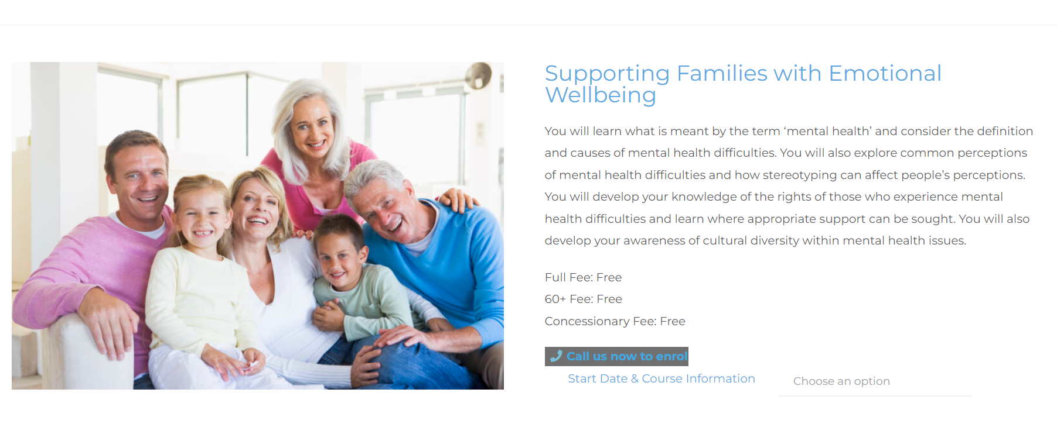
https://haveringadultcollege.co.uk/product/raising-confident-children/
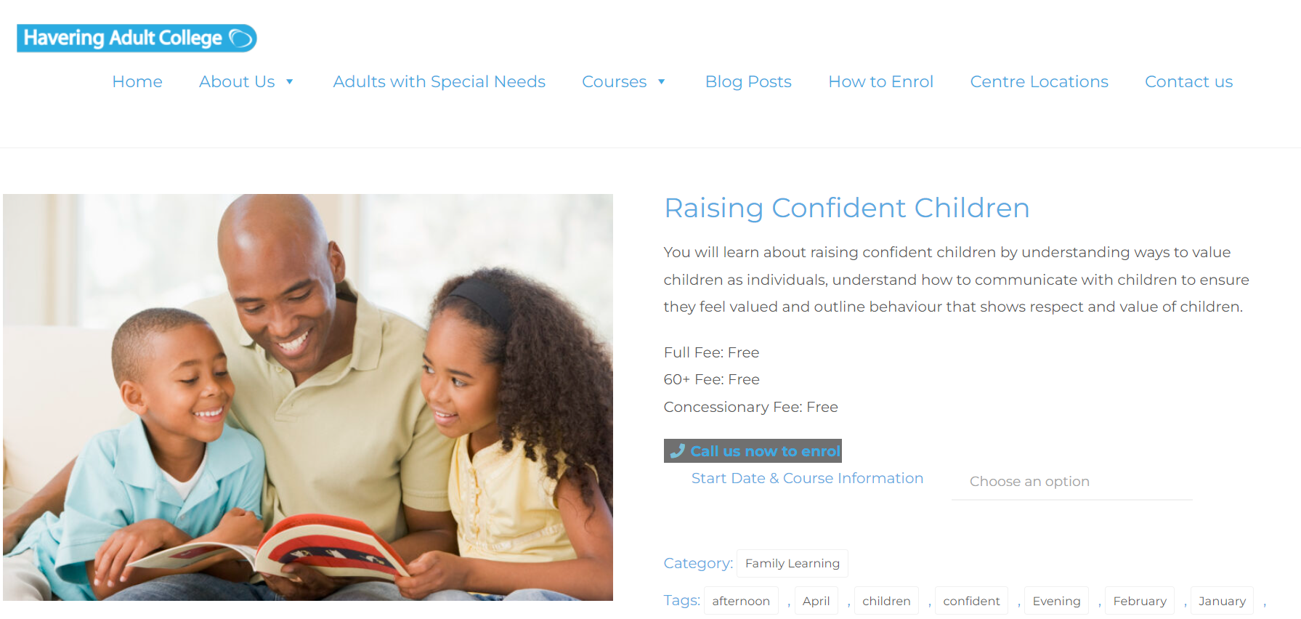

https://haveringadultcollege.co.uk/product/supporting-families-with-autism/
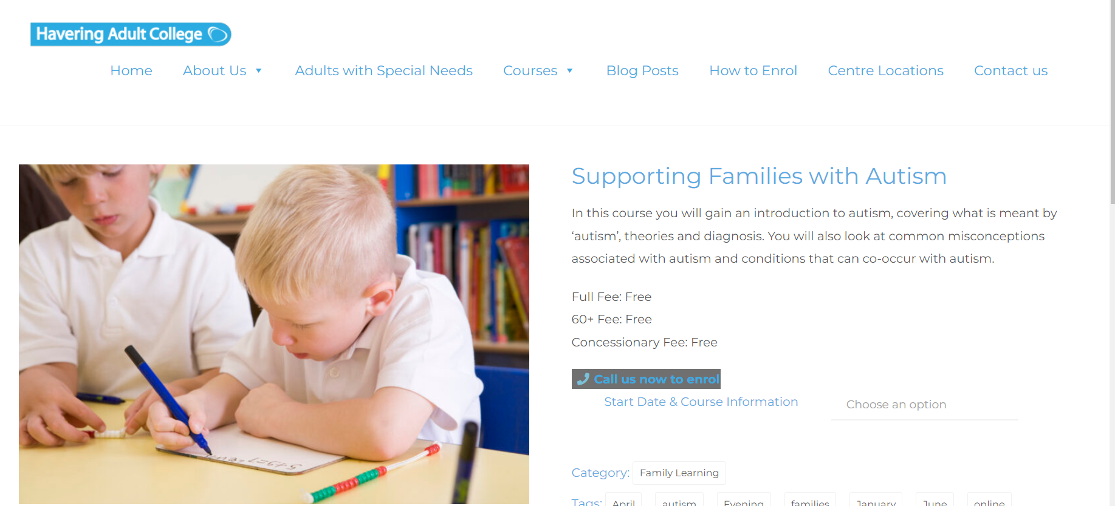

https://haveringadultcollege.co.uk/product/understanding-challenging-behaviour/
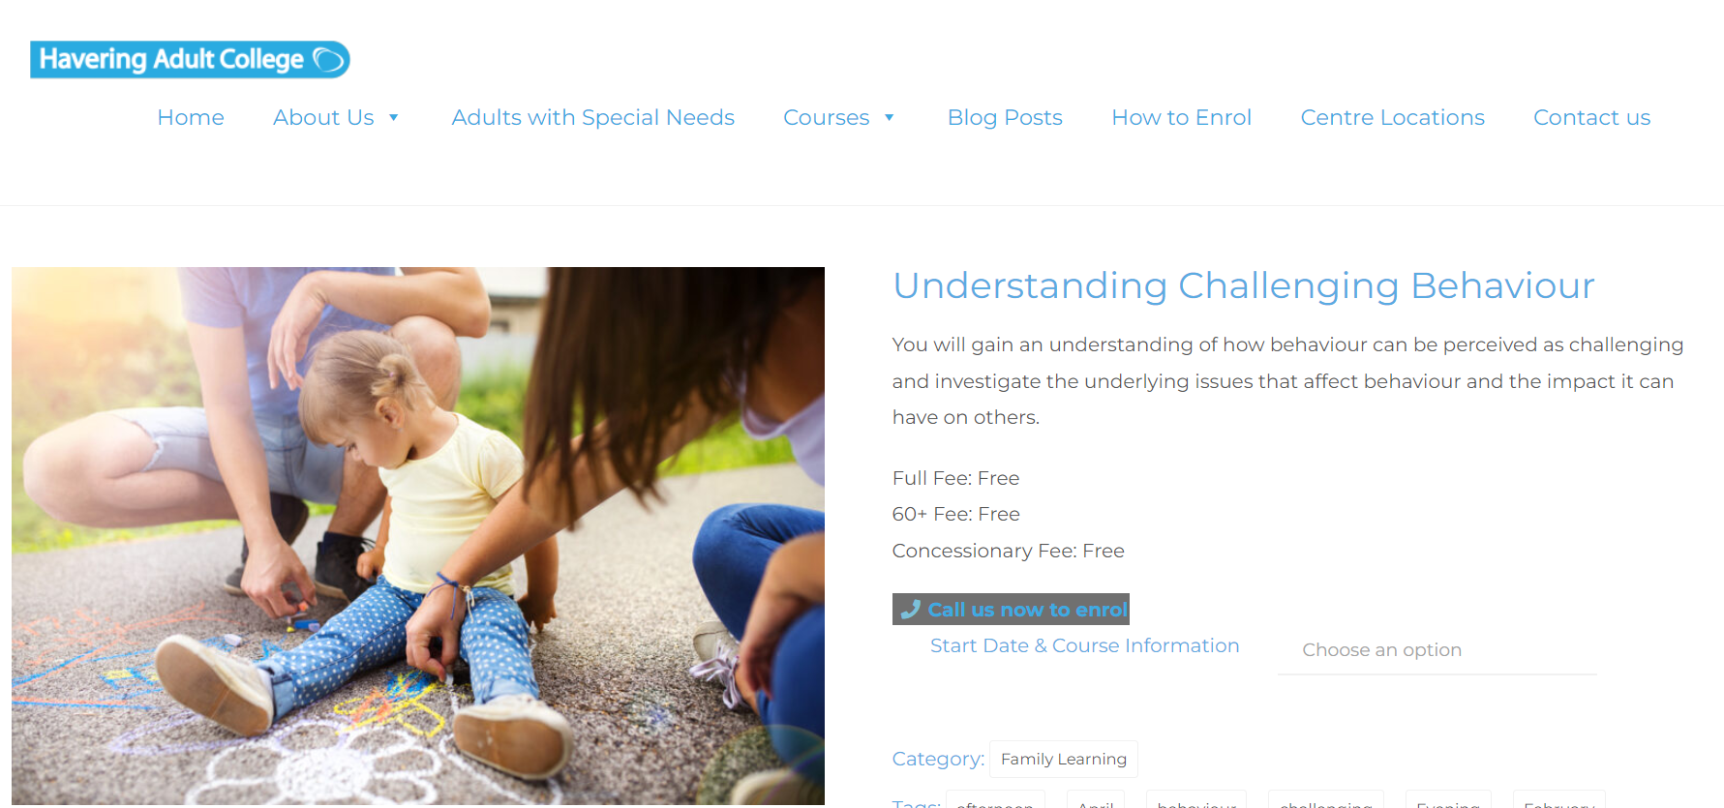

https://haveringadultcollege.co.uk/product/9-weeks-family-learning-course/
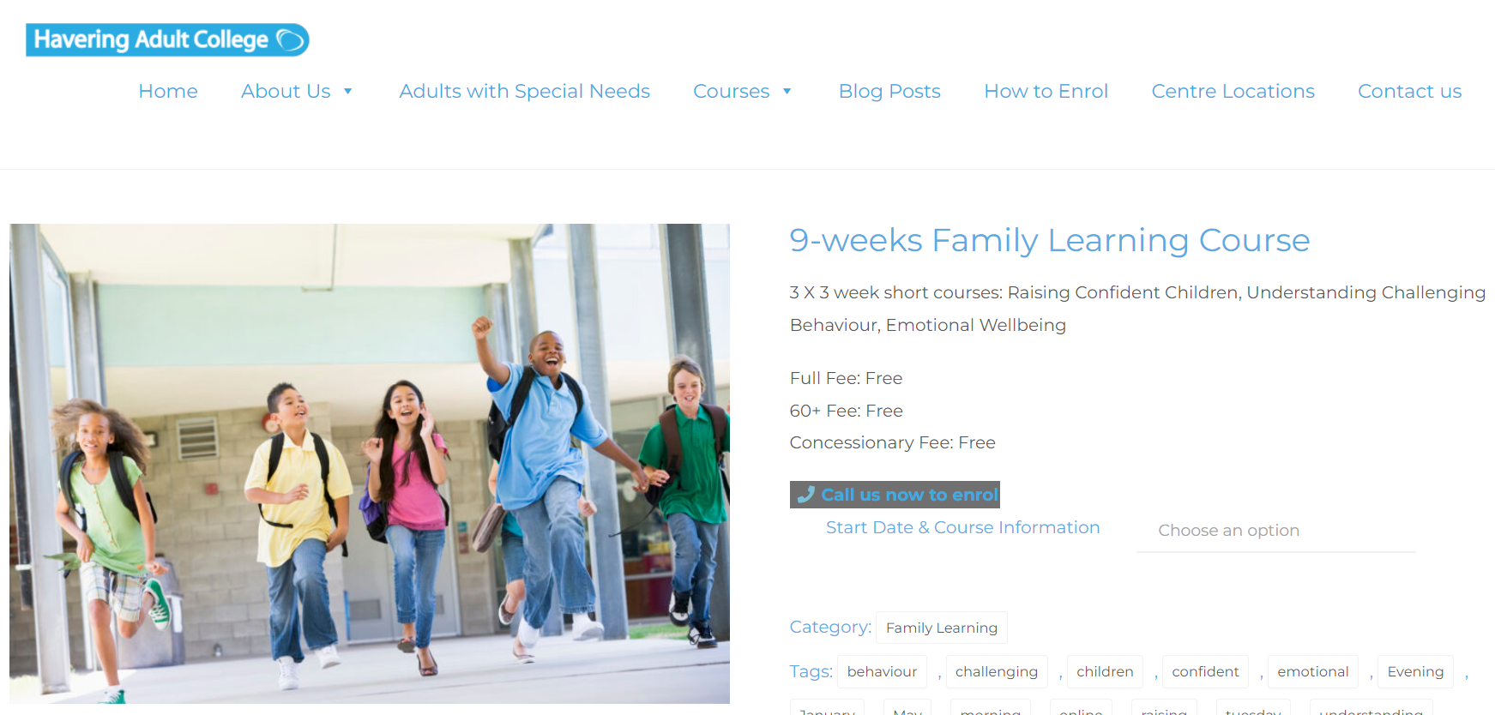

https://haveringadultcollege.co.uk/product/awareness-of-the-risk-of-gaming-and-gambling-to-children/

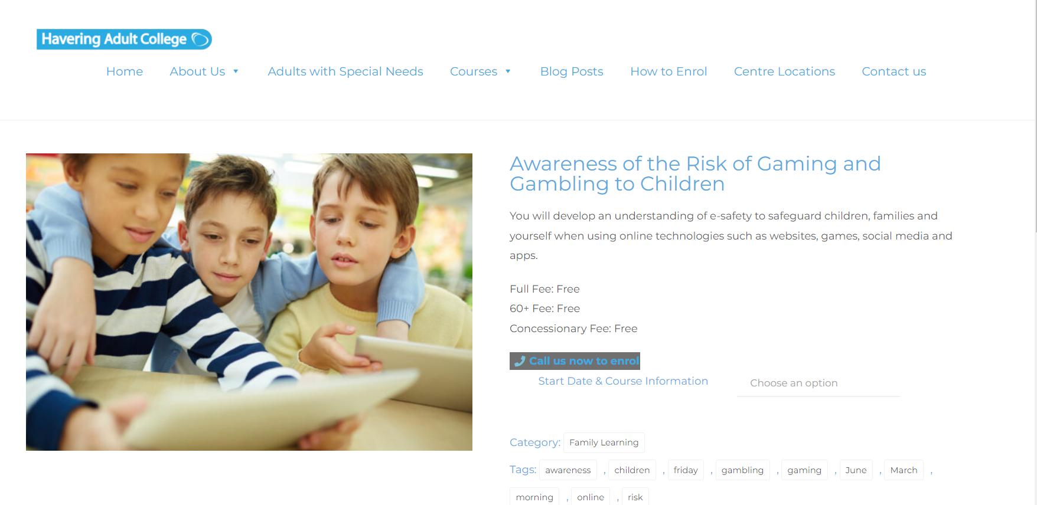

https://haveringadultcollege.co.uk/product/supporting-families-and-young-people-with-health-relationships/

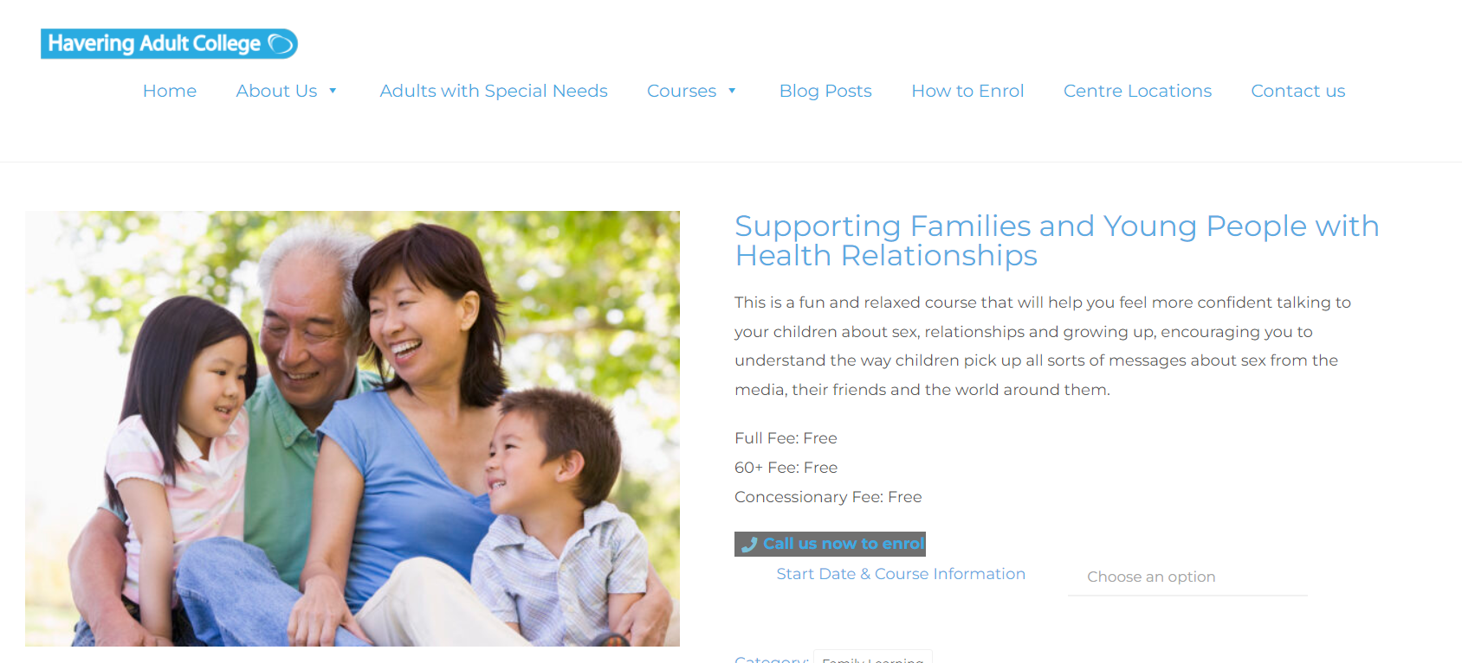

https://haveringadultcollege.co.uk/product/maths-skills-for-life-units-entry-level-2-3/

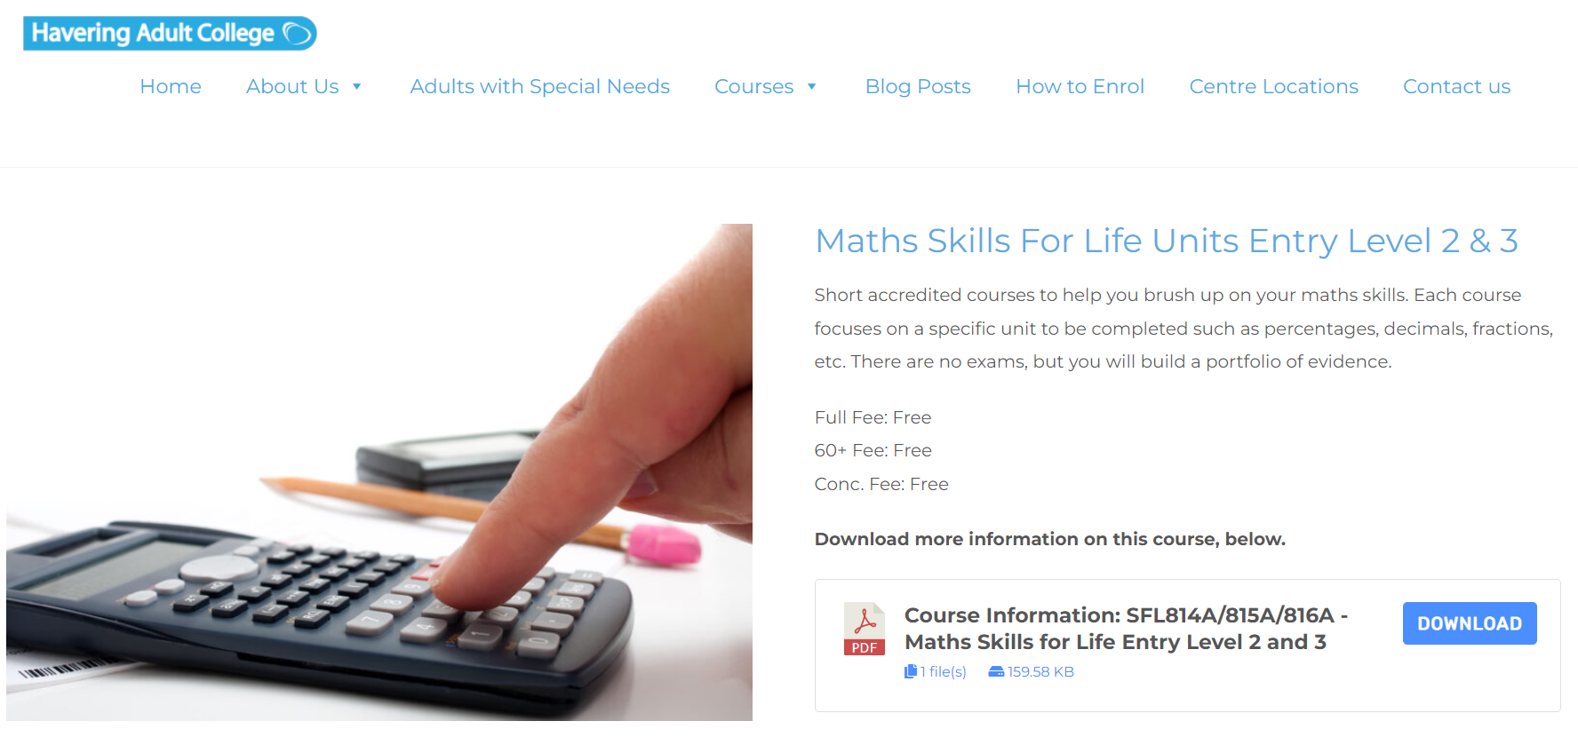

https://haveringadultcollege.co.uk/product/english-maths-skills-for-life-combined-entry-1/

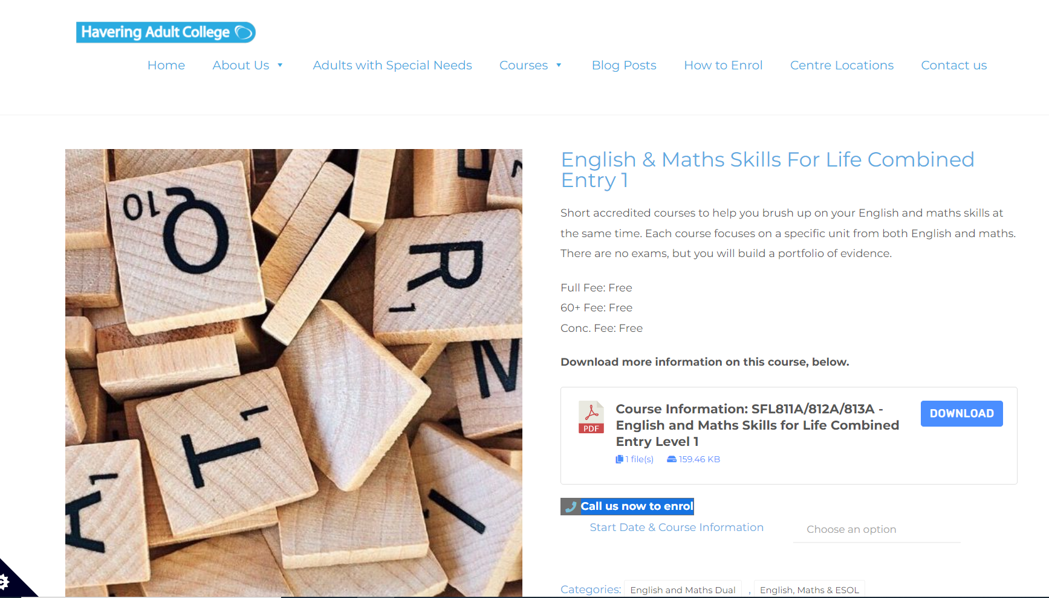

https://haveringadultcollege.co.uk/product/english-maths-skills-for-life-combined-entry-1/


