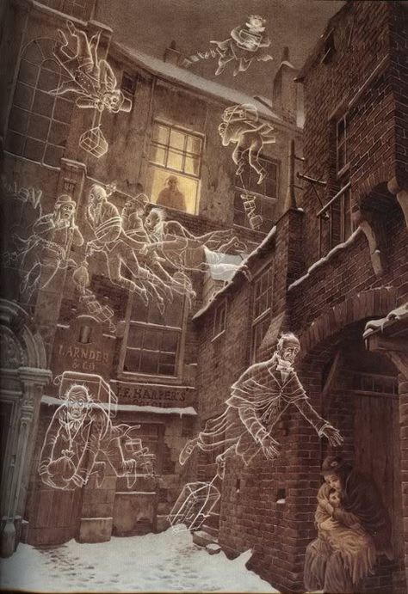
A Christmas Carol – Year 11 Workbook
Name: Class:
Contents
- Dickens: Purpose and rhetoric
- Scrooge: A symbol of cruelty and selfishness
- Marley's ghost: A warning
- The Ghost of Christmas Past: The power of memory
- Scrooge's past: A catalyst for change
- The Ghost of Christmas Present: The Christmas ideal
- The Cratchit Family: Humanising the lower classes
- Ignorance and Want: Society's cruelty
- The Ghost of Christmas Yet To Come: A moral reckoning
- Death: Grief and regret
- A Changed Man: Familiar faces
- Scrooge's journey: From avarice to benevolence

Dickens: Purpose and rhetoric
Stave: Context  LO: To revise Dickens’ purpose and rhetoric in writing the novella. | Vocabulary  1. Allegory  2. Austerity  3. Asceticism  4. Didactic  5. Diatribe
Recap and recall
- List three quotations that link to the themes of Animal Farm
- Explain three ways society changed between 1912 and 1945.
- Explain three of Orwell’s aims in writing Animal Farm.
- Explain one interpretation of the ending of Animal Farm.
New learning
Task: Read through the following information regarding Dickens’ purpose in writing A Christmas Carol. Use the margin to make notes of key points.  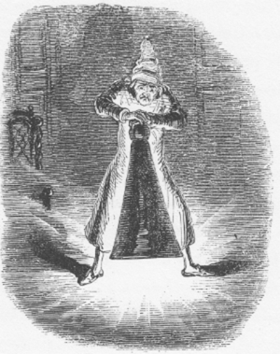  A Christmas Carol as an allegory  A Christmas Carol is an allegory in that it features events and characters with a clear, fixed symbolic meaning. In the novella, Scrooge represents all the values that are opposed to the idea of Christmas--greed, selfishness, and a lack of goodwill toward one's fellow man. The Ghost of Christmas Past, with his glowing head symbolizing the mind, represents memory; the Ghost of Christmas Present represents generosity, empathy, and the Christmas spirit; and the Ghost of Christmas Yet to Come represents the fear of death and moral reckoning. The Cratchits represent the poor, whom Dickens portrays with warmth and sympathy while seeking to draw attention to their plight. With such clear symbolic meanings, it is evident that Dickens’ novella reaches beyond the aims of simply telling a riveting Christmas tale.  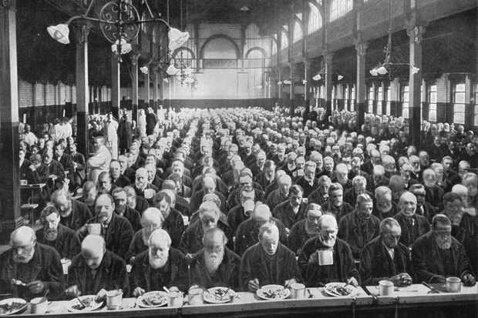  Social criticism  Social Commentary--particularly those statements directed at the Poor Laws governing the lower classes during Dickens' time--plays an important role in A Christmas Carol. The Poor Laws imposed an obligation on every parish to take care of its poor, but often to preserve order than to show compassion. The Poor Laws saw many people unable to work – perhaps being ill, destitute, old or orphaned – were put into ‘workhouses’ or ‘poorhouses’. Those able to work, but whose wages were too low to support their families, received ‘relief in aid of wages’ in the form of food and clothes. Dickens often uses Scrooge as a mouthpiece to express the more callous justifications and excuses used to defend the harsh treatment of the poor.  Thomas Malthus' theory that anyone who could not support himself did not have a right to live is a good example of these outrageous claims. Malthus believed that poverty and famine were God’s way of preventing man from being lazy. Asked whether he wishes to support a charity, Scrooge replies in a voice that echoes Malthus; he states that he does support charities--prisons and workhouses, which are all the charity the poor need. Dickens harshly criticizes these attitudes and presents a highly sympathetic view of the poor through his depiction of the Cratchits. Arguably, the novella is a didactic and political diatribe, offering a moral warning for the consequences of greed.  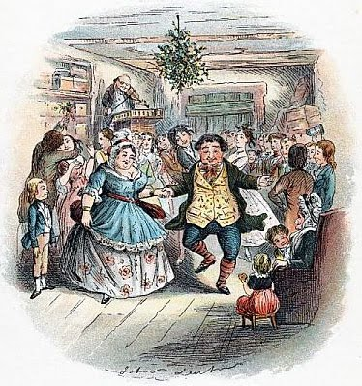  Religious austerity and asceticism  Dickens also uses the novella to criticise the religious ideals of austerity and asceticism that were prevalent in the 19th century. Through a depiction of Christmas as a time of lavish celebration and great feasts, Dickens helped create a vision of Christmas that rejected austerity in favour of community, good spirit, prosperous celebration, generosity and benevolence. The novella helps to convey the idea that it is not immoral to possess riches or to celebrate as these things can bring great happiness to others – instead, the novella argues that immorality is born from a refusal to share one’s wealth, rather than possessing it in the first place. Dickens’ depictions of Christmas and skewing of moral standards helped to refine a contemporary conception of the Christmas holiday.  Glossary  1. Allegory – A story that can be interpreted to reveal a hidden meaning, typically a moral or political one.  2. Austerity – A sternness or severity of manner or attitude, where one might deliberately and rigidly reduce their standard of living.  3. Asceticism – Severe self-discipline and avoidance of all forms of indulgence, often for religious reasons.  4. Didactic – Intended to teach, often as moral instruction.  5. Diatribe – A forceful attack against someone or something. |  | Key Points
Quiz
Answer the following questions in full sentences:
- Why is the novella considered an allegory?
- What is one of the novella’s didactic purposes?
- Why do some consider the novella a diatribe?
- What does Dickens seem to support as opposed to austerity and asceticism?
- Why does Dickens argue that wealth and prosperity in and of itself is not immoral?
Key Quotations
Explode the following key quotations for this extract.
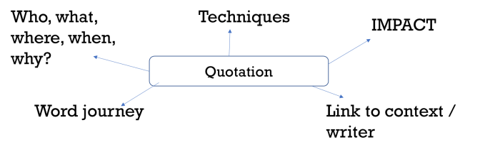
Thomas Malthus: “It has appeared that from the inevitable laws of our nature, some human beings must suffer from want. These are the unhappy persons who, in the great lottery of life, have drawn a blank.”

Dickens: “No one is useless in this world who lightens the burden of another.”

Review
Write an introduction that summarises Dickens’ aims for the following question:

To what extent is A Christmas Carol a political and social diatribe?

Scrooge: A symbol of cruelty and selfishness
Stave: 1  LO: To evaluate how Dickens introduces Scrooge as a symbol of cruelty and selfishness. | Vocabulary  1. Callous  2. Cruel  3. Avaricious  4. Miserly  5. Irreligious
Recap and recall
- Why is the novella considered an allegory?
- What is one of the novella’s didactic purposes?
- Why do some consider the novella a diatribe?
- What does Dickens seem to support as opposed to austerity and asceticism?
- Why does Dickens argue that wealth and prosperity in and of itself is not immoral?
New learning
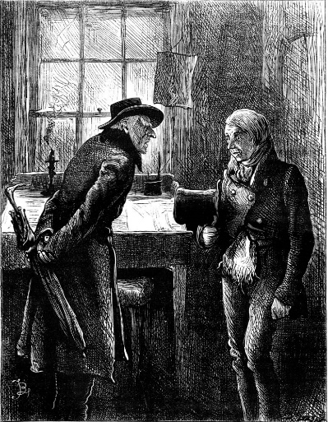

Task: Read the opening of the first stave until the arrival of Marley’s Ghost.

Identify textual references that exemplify the following descriptions of Scrooge, Bob Cratchit and Fred.

Scrooge
Vocabulary | Textual reference
Callous
Cruel
Avaricious
Miserly
Irreligious

Bob Cratchit
Vocabulary | Textual reference
Exploited
Taken for granted
Mistreated

Fred
Vocabulary | Textual reference
Jovial
Spirited
Benevolent

Quiz
Answer the following questions in full sentences:
- What ideas about Scrooge are foregrounded in the opening of the novella?
- What might ‘the clerk’s fire’ symbolise?
- How does Scrooge echo Thomas Malthus’s attitude to charity?
- To what does Fred invite Scrooge, and what does this symbolise?
- How does Dickens juxtapose Scrooge and Fred?
Key Quotations
Explode the following key quotations for this extract.
Scrooge

“Hard and sharp as flint”

“Solitary as an oyster”

“Are there no prisons? Are there no workhouses?”

“It’s not my business”

Bob Cratchit

“The clerk’s fire was so very much smaller… like only one coal”

Fred

“What reason have you to be morose? You’re rich enough.”

“Christmas is a good time, a kind, forgiving, charitable, pleasant time.”

Application
Task: Construct a thesis statement for each of the following questions.

- How does Dickens underline the cruelty and selfishness of the upper classes?
- How does Dickens symbolise the suffering of the lower classes?
- How does Dickens reject religious asceticism and austerity through Fred?

English Language Exam Practice
English Language Paper 1 Question 2 / Paper 2 Question 3
How does Dickens use language to introduce the character of Scrooge?

You could analyse:
- Words and phrases
- Language devices
- Sentence forms

Remember to:
- Use the TEA structure
- Focus on IMPACT
- Focus on effects on the reader

Marley's ghost: A warning
Stave: 1  LO: To evaluate how Dickens uses Marley’s ghost as an allegorical warning against greed and avarice. | Vocabulary  1. Avaricious  2. Doomed  3. Foreboding
Recap and recall
- What ideas about Scrooge are foregrounded in the opening of the novella?
- What might ‘the clerk’s fire’ symbolise?
- How does Scrooge echo Thomas Malthus’s attitude to charity?
- To what does Fred invite Scrooge, and what does this symbolise?
- How does Dickens juxtapose Scrooge and Fred?
New learning
Task: Read to the end of Stave 1.

Annotate the image of Marley’s Ghost with the different themes that Dickens establishes through his early appearance in the novella. What themes does Dickens foreground as vital to the novella, and how does he do this?

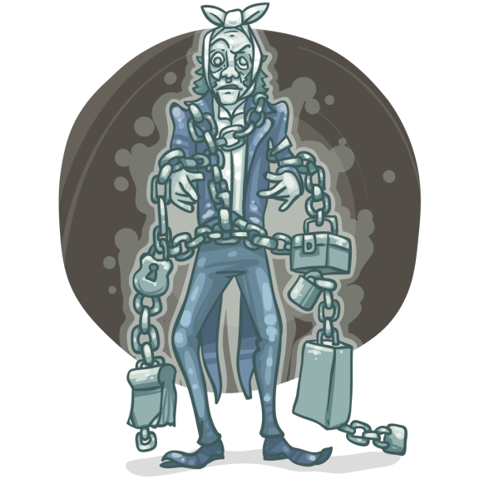

Quiz
Answer the following questions in full sentences:
- What is the ghost’s purpose in visiting Scrooge?
- What does the ghost’s visit underline about Scrooge’s character?
- Why is Marley’s ghost doomed?
- How does Marley’s ghost echo Scrooge’s earlier words, ‘It’s not my business’?

Key Quotations
Explode the following key quotations for this extract.
“I wear the chain I forged in life”

“Cash boxes… ledgers… heavy purses”

“Mankind was my business"

Application
How does Dickens present ideas about morality in this extract and the novella as a whole?

Remember to plan for success:
- Upgrade the question and develop a thesis.
- Identify three sequential points/arguments.
- Identify relevant evidence.
- Explode evidence.
English Language Exam Practice
English Language Paper 1 Question 3
How does Dickens structure this part of the novella to interest readers?

You could write about:
- How Dickens focuses your attention at the beginning of the extract
- How and why Dickens changes focus
- Any other structural features that interest you

Remember to:
- Answer ‘What, how, why?’
- Think like a camera
- Use structural vocabulary like:
  - Foregrounds
    - Establishes
    - Introduces
    - Foreshadows
    - Sparks
  - Change of focus
    - Reveals
    - Develops
    - Builds
    - Concludes
    - Resolves
    - Echoes
Review
Write a 50 word summary of Stave 1.

