AQA English Literature Paper 1

Macbeth

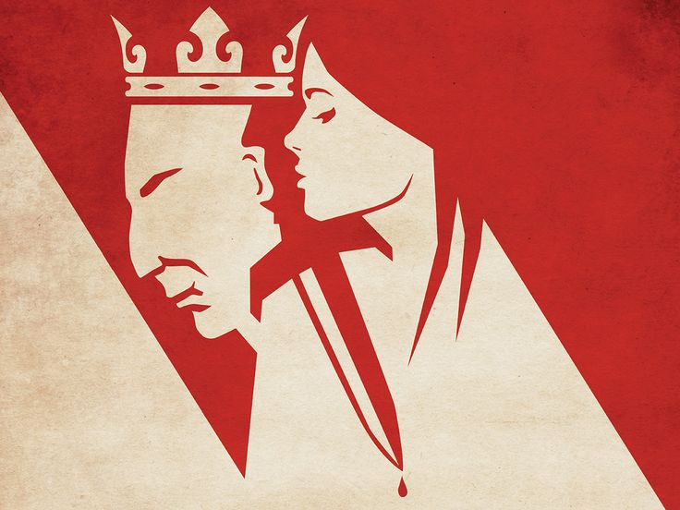

Revision booklet

In the exam, you will be presented with a short extract from the play.

The question will ask you to focus on the extract (examiners expect to see close language analysis) and then relate it to elsewhere in the play, so you can show your understanding of the whole play.

You are advised to spend 45 minutes writing your response to Macbeth and then 5 minutes carefully proof-reading it for SPAG accuracy!

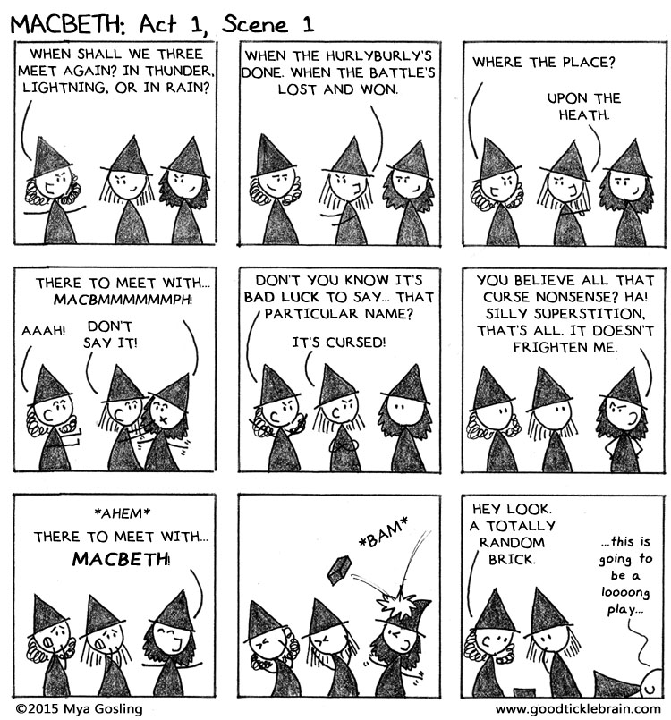

Macbeth: ‘a chain of events’

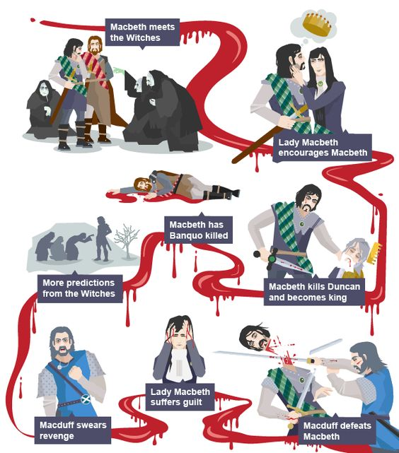

Character Analysis: Lady Macbeth

Lady Macbeth is the deuteragonist in this drama: the wife of Macbeth, she shares his lust for power. Our initial impressions of Lady Macbeth are that she is, as Malcolm describes her at the close of the play, indeed “fiend-like” as, when she learns of Duncan’s visit to Dunsinane her thoughts turn immediately to regicide. Without pause, she summons evil “spirits” and commands them to “make thick my blood” so that “no compunctious visitings of Nature” shake her wicked intention to murder the King.

Interestingly, in this soliloquy Lady Macbeth imagines committing the regicide herself as she asks to be wrapped in the blackest smoke of Hell “so that my keen knife sees not the wound it makes.” Later, she privately admits in an aside: “Had he not looked like my father as he slept, I had done’t,” suggesting that Lady Macbeth is not as “fiend-like” as is sometimes argued. Certainly, she is not naturally “fiend-like” or she would not have sought assistance from the “murdering ministers” she conjures when the audience first meet her, even though she willingly submits to their wicked influence.

It is arguable that Lady Macbeth is subconsciously repelled by the thought of regicide because when she is pressuring her husband to commit the deed she avoids using the word “murder”; instead she employs a variety of euphemisms, including: “this enterprise”, Duncan being “provided for” or merely “it”. However, others argue that Shakespeare’s employment of euphemisms here is quite deliberate and serves subtly to convey Lady Macbeth’s wily, artful manipulation of her husband and which, therefore, strengthens the audience impression of her as being truly “fiend-like”.

However, once the regicide is committed and Lady Macbeth becomes Queen, the dynamics of her relationship with Macbeth undergoes a dramatic transformation. Despite having fulfilled her ambition to become Queen, in an aside to the audience Lady Macbeth privately admits: “Nought’s had, all’s spent, where our desire is got without content.” Ironically, when her husband then enters her own face becomes a mask, disguising what is in her heart as she admonishes Macbeth for entertaining gloomy thoughts which ought to have been buried alongside the body of the dead King Duncan.

As her ability to influence her husband diminishes – he simply ignores her command to halt his murderous plans for Banquo when she demands: “You must leave this” – Lady Macbeth becomes an increasingly isolated figure. After the banquet scene at which Macbeth arouses suspicions by his erratic behaviour, Lady Macbeth tells him: “You lack the season of all natures – sleep.” Ironically, the audience’s final impressions of her are in Act 5 scene 1 where she is sleepwalking, burdened by guilt.

The bold figure who instructed evil spirits to “pall thee in the dunnest smoke of Hell” is now a pathetic figure, afraid of the dark. Lady Macbeth’s gentlewoman tells the Doctor observing her sleepwalk: “She has light by her continually – ‘tis her command.” The evil she so willingly embraced betrays her – as it betrays Macbeth – and produces only anguish in place of the rewards she had envisioned. On the night of Duncan’s murder, their hands bathed in Duncan’s blood, she boldly claimed: “A little water clears us of this deed.” Now, however, she seems unable to rid herself of the stench and spots of blood she imagines cover her hands still. The Doctor fears she is suicidal and claims: “more needs she the Divine than the physician.”

Character analysis: Macbeth

Macbeth is the protagonist in this tragedy: a tragic hero whose hamartia – the fatal flaw in his character - is his ambition, a lust for power shared by his wife. He is aware of the evil his ambition gives rise to but he is unable to overcome the temptation.

Often, Lady Macbeth is wrongly accused of inviting Macbeth to contemplate regicide. In fact, after his encounter with the witches in Act 1 scene 3, Macbeth himself considers regicide when he reflects on their prophecy and admits:
“If good, why do I yield to that suggestion
Whose horrid image doth unfix my hair
And make my seated heart knock at my ribs,
Against the use of nature?”

He is here acknowledging that the thing he is contemplating – usurping King Duncan’s crown - is “against the use of nature.”

Wracked by doubts, in Act 1 scene 7 as he contemplates the regicide, Macbeth wavers and informs his wife: “We will proceed no further in this business.” Unlike his wife’s wily, artful avoidance of the word “murder” during this conversation, it is clear that Macbeth uses a euphemism here because the very thought of murder frightens him, let alone the deed. Even when criticised and challenged by Lady Macbeth, he retains the moral sensibility to declare: “I dare do all may become a man. / Who dares do more is none.”

Having submitted to his wife’s artful persuasion, Macbeth kills Duncan but is immediately plagued by his conscience. He tells how he “could not say Amen” and of a voice that foretold sleeplessness as punishment for such a heinous act.

Though Macbeth is influenced by both the witches and his wife, Macbeth is not controlled by them. His story is one of moral choice and the consequences of that choice. Once Duncan is murdered, Macbeth withdraws from Lady Macbeth and all subsequent murders in this play are the products of Macbeth’s own paranoia and desperate desire to cling to power “on this bank and shoal of time” here on Earth, knowing he has been condemned to an eternity in Hell for killing God’s anointed representative on Earth.

Having murdered Banquo and Macduff’s family, Macbeth’s paranoia gives way to a more fundamental disorder. In Act 5 we watch as he prepares to defend his kingdom – reduced to his castle at Dunsinane – and he swings violently between fits of rage and despair. Evidently, he has lost any emotional connection to his fellow men, declares that he is “sick at heart” and has “lived long enough”. When informed of his wife’s death, he is completely unmoved and instead reflects on the meaningless of life itself. Macbeth is a tragic hero precisely because he does not accept his evil callously; he suffers for it. In his own words: “To know my deed, ‘twere best not know myself.”

Character Analysis: Banquo

Banquo might best be described as a minor character in the tragedy of Macbeth. Nevertheless, he has an important function in the play and is considered by many to be an effective dramatic foil for Macbeth. It is through Banquo’s interactions with Macbeth and his own motivations that the audience – through contrast – gain insights into Macbeth’s nature also.

Alike in many ways, Banquo and Macbeth are equals as the play begins: both are Scottish “captains” defending Duncan’s realm against the marauding Norweyans led by Sweno. They fight honourably and are heroic warriors, risking their lives in defence of Duncan’s kingdom. However, after the battle when they encounter the “weird sisters” on the “blasted heath”, Banquo’s dramatic function is to demonstrate to an audience that the temptations of the witches may be successfully resisted and that Macbeth therefore acts from free will. Banquo expresses unshakeable moral principles and warns his friend that the witches may well be “instruments of darkness” who “tell us truths” in order to “win us to our harm” and to “betray us in deepest consequence.” Banquo’s concern contrasts strikingly with Macbeth’s own susceptibility to the witches.

Banquo’s resistance to the influence of evil serves to highlight Macbeth’s failure to resist and foregrounds his tendency towards evil, stimulated by ambition - the flaw that makes the tragedy possible.

Prompted by paranoid insecurity, when Macbeth decides to murder Banquo he acknowledges Banquo’s endearing qualities: his “royalty of nature”, his “wisdom” and his “dauntless” or fearless nature. This resentment of Banquo's natural superiority, together with jealousy of his destiny as a “father to a line of kings”, motivates Macbeth to commit further wicked murders in the second half of the play, commencing with Banquo’s and the attempted murder of his son and heir, Fleance.

Banquo’s fate is determined by his virtue, just as Macbeth’s is determined by his villainy.

Character Analysis: The Weird Sisters (Witches)

The weird sisters are an unholy trinity, a trio of malevolent, supernatural characters whose function in the drama is to encourage Macbeth in his evil inclinations.

Though their appearances in the play are brief, they have an important function. Shakespeare establishes the supernatural theme via their association with disorder in Nature: they appear amid thunder and lightning in a grim meeting on a “blasted heath” which contributes greatly to the tone of mysterious evil which pervades the play.

Likewise, the supernatural world they represent is terrifying to an audience because it is beyond human control and in the play it is symbolic of the unpredictable force of human desire, such as Macbeth’s ruthless ambition to become King.

At their first appearance, the weird sisters state an ambiguity that Shakespeare weaves through the play: “Fair is foul, and foul is fair.” Indeed, the witches’ relationship with Macbeth is so entwined that the first line he speaks in the play is an echo of this riddle. He says: “So fair and foul a day I have not seen.”

The deceptive pictures of the future – in their initial prediction of Macbeth becoming King and later in the riddles given by the Apparitions which rise from the cauldron when Macbeth visits the witches for a second time – encourage in Macbeth and Lady Macbeth a false sense of what is desirable and possible. The magic of the witches, then, is their ability to create moral disruption which, in Macbeth’s case, leads to his death and subsequent damnation.

It is important to remember that while the witches may have “more in them than mortal knowledge”, they do not control Macbeth. They merely put ideas into his mind on which he then decides for himself. He is the master of his own destiny and acts out of free will.

At this point in the play, Banquo and Macbeth have just met the witches. The witches have just told Macbeth he will one day be the King of Scotland.

BANQUO  Good sir, why do you start; and seem to fear  Things that do sound so fair? I' the name of truth,  Are ye fantastical, or that indeed  Which outwardly ye show? My noble partner  You greet with present grace and great prediction  Of noble having and of royal hope,  That he seems rapt withal: to me you speak not.  If you can look into the seeds of time,  And say which grain will grow and which will not,  Speak then to me, who neither beg nor fear  Your favours nor your hate.  First Witch  Hail!  Second Witch  Hail!  Third Witch  Hail!  First Witch  Lesser than Macbeth, and greater.  Second Witch  Not so happy, yet much happier.  Third Witch  Thou shalt get kings, though thou be none:  So all hail, Macbeth and Banquo!  First Witch  Banquo and Macbeth, all hail!  MACBETH  Stay, you imperfect speakers, tell me more:  By Sinel's death I know I am thane of Glamis;  But how of Cawdor? The thane of Cawdor lives,  A prosperous gentleman; and to be king  Stands not within the prospect of belief,  No more than to be Cawdor. Say from whence  You owe this strange intelligence? or why  Upon this blasted heath you stop our way  With such prophetic greeting? Speak, I charge you.  (The Witches vanish) | 5  10  15  20  25

Q1: Starting with this conversation, explain how far Shakespeare presents Macbeth as a character who believes in the supernatural power of the witches.
Write about:
- How Shakespeare presents Macbeth’s reaction to the witches here
- How Shakespeare presents his beliefs in them elsewhere in the play.
Things to read / think / write about:

READ the character analysis of the Witches

- Macbeth’s dramatic reaction to the predictions delivered by the “weird sisters”. It is so striking that Banquo observes Macbeth’s facial expression and addresses him directly (see lines 1 – 2).

- Banquo’s remark to the witches about Macbeth being “rapt withal”. Discuss the significance of this in the context of Macbeth’s belief in the supernatural.

- Shakespeare’s choice of imperative verbs when Macbeth commands the weird sisters (twice on line 20 and again on line 28).

- The significance of a series of questions addressed directly to the witches and Shakespeare’s choice of diction in Macbeth’s opinion that the witches possess “strange intelligence”. What does this series of questions convey to an audience about Macbeth’s belief in, and attitude towards, the supernatural?

- Consider the use of dramatic irony here, too. The audience is aware that Duncan has decreed the title Thane of Cawdor is to pass to Macbeth for his bravery in battle. Is Shakespeare trying to shape the audience’s opinion of belief in the supernatural?

- Consider Macbeth’s aside shortly after the first prediction is realised when Ross brings news that Duncan has bestowed the title Thane of Cawdor on Macbeth. In an aside, Macbeth reflects on the encounter and remarks: “This supernatural soliciting/Cannot be good, cannot be ill.” Discuss the significance of Macbeth’s uncertainty about the supernatural being good or evil here.

- Contrast this with Banquo’s very different reaction to the witches and the advice he gives to Macbeth: “And oftentimes, to win us to our harm,
The instruments of darkness tell us truths,
Win us with honest trifles, to betray's
In deepest consequence.”

- Macbeth’s ignorance of Banquo’s advice and later visit to the witches. Explain what motivates him to visit them and what this conveys to an audience about his belief in their abilities, given his later bold claim that he bears “a charmed life” which “must not yield / To one of woman born.”

- The futility and irony of Macbeth’s final comment in the play, to Macduff: “damned be he who first cries, ‘Hold – enough!’” in the context of having already surrendered his soul to the devil for committing the act of regicide.

Macbeth

Read the following extract from Act 1 Scene 5 of Macbeth and then answer the question that follows.

At this point in the play Lady Macbeth is speaking. She has just received the news that King Duncan will be spending the night at her castle.

The raven himself is hoarse  That croaks the fatal entrance of Duncan  Under my battlements. Come, you spirits  That tend on mortal thoughts, unsex me here,  And fill me from the crown to the toe top-full  Of direst cruelty! make thick my blood;  Stop up the access and passage to remorse,  That no compunctious visitings of nature  Shake my fell purpose, nor keep peace between  The effect and it! Come to my woman's breasts,  And take my milk for gall, you murdering ministers,  Wherever in your sightless substances  You wait on nature's mischief! Come, thick night,  And pall thee in the dunnest smoke of hell,  That my keen knife see not the wound it makes,  Nor heaven peep through the blanket of the dark,  To cry 'Hold, hold!' | 5  10  15

Q1: Starting with this speech, explain how far you think Shakespeare presents
Lady Macbeth as a powerful woman.

Write about:
• how Shakespeare presents Lady Macbeth in this speech
• how Shakespeare presents Lady Macbeth in the play as a whole. [30 marks]
SPAG [4 marks]

Things you might write about:

- The connotations of the “raven” and her use of the adjective “fatal” to describe Duncan’s entrance to Dunsinane castle. What does it convey about her immediate thoughts and reactions to Macbeth’s letter?

- Summoning evil spirits. Explain clearly what Lady Macbeth invites the “murdering ministers” to do to her body and why she requests their assistance.

- The fact she imagines committing the regicide herself in this soliloquy: she refers to the weapon as “my keen knife”. However, she does not later commit the crime herself. What reason does she give for not doing so, in an aside to the audience in Act 2 scene 2, lines 15 – 16? Explain what impressions this private admission conveys about Lady Macbeth’s character to the audience.

- Think now about Act 3 scene 2, where we first see Lady Macbeth as Queen. In an aside to the audience at the opening of this scene, explain what feelings she privately admits to, now that her ambition to be queen has been fulfilled.

- Now think about our final impressions of Lady Macbeth, in Act 5 scene 1. Write about the significance of having “light by her continually” and how this links to her desire to be wrapped in “the dunnest smoke of Hell” when first contemplating Duncan’s murder. Explain also the irony of her constantly rubbing her hands, given her comment to Macbeth on the night of Duncan’s murder: “A little water clears us of this deed.”

KEY WORD VOCABULARY: try to use these words in your response. Check spelling of key terms.

soliloquy audience impression initial admission ambitious

fiendish determined callous ironic significant aside

At this point in the play, Macbeth has decided he will not kill King Duncan. He is just about to share this news with his wife, Lady Macbeth.

MACBETH  We will proceed no further in this business:  He hath honour'd me of late; and I have bought  Golden opinions from all sorts of people,  Which would be worn now in their newest gloss,  Not cast aside so soon.  LADY MACBETH  Was the hope drunk  Wherein you dress'd yourself? hath it slept since?  And wakes it now, to look so green and pale  At what it did so freely? From this time  Such I account thy love. Art thou afeard  To be the same in thine own act and valour  As thou art in desire? Wouldst thou have that  Which thou esteem'st the ornament of life,  And live a coward in thine own esteem,  Letting 'I dare not' wait upon 'I would,'  Like the poor cat i' the adage?  MACBETH  Prithee, peace:  I dare do all that may become a man;  Who dares do more is none.  LADY MACBETH  What beast was't, then,  That made you break this enterprise to me?  When you durst do it, then you were a man;  And, to be more than what you were, you would  Be so much more the man. | 5  10  15  20

Q1: Starting with this conversation, explain how far you think Shakespeare
presents Lady Macbeth as the dominant partner in this relationship.

Write about:
• how Shakespeare presents Lady Macbeth in this speech
• how Shakespeare presents Lady Macbeth elsewhere in the play. [30 marks]
SPAG [4 marks]
Things to think and write about:

FIRST – Read the character analysis of Lady Macbeth. Highlight useful points and consider where you might synthesise them into your response.

- Comment on Lady Macbeth’s violent emotional reaction to Macbeth’s decision. Comment on Shakespeare’s choice of imagery here, where Macbeth’s “hope” is personified by Lady Macbeth in a scathing criticism of his cowardice (see lines 6 to 9).

- Comment on Macbeth’s attempt to assert his dominance in this exchange (see lines 17 to 19). Is it successful? What is Macbeth’s view of murder here? How is it different from hers?

- Her use of euphemisms (on lines 21 and 22) to cleverly avoid having to use the word “murder”, given Macbeth’s announcement in this exchange that he will not commit the deed. How does this show her dominance in their relationship?

- Explain how the dynamics of their relationship changes once Macbeth usurps Duncan’s throne. Consider their disagreement over Macbeth’s plans for Banquo in Act 3 scene 2. How does Lady Macbeth try to assert her dominance in that conversation (see Act 3 Scene 2, lines 25 to 40)? Is she successful?

- Our final impressions of her: a pitiable, tragic and troubled woman, frightened of the “dunnest smoke of Hell” she so willingly asked to be wrapped in at the beginning of the play.

This is from Act 3 scene 1 of the play. At this point in the play, Macbeth is now king of Scotland. His friend Banquo expresses his private fears that Macbeth was involved in the murder of King Duncan.

BANQUO  Thou hast it now: king, Cawdor, Glamis, all,  As the weird women promised, and, I fear,  Thou play'dst most foully for't: yet it was said  It should not stand in thy posterity,  But that myself should be the root and father  Of many kings. If there come truth from them--  As upon thee, Macbeth, their speeches shine--  Why, by the verities on thee made good,  May they not be my oracles as well,  And set me up in hope? But hush! no more.  Enter MACBETH, as king, LADY MACBETH, as queen, LENNOX, ROSS, Lords, Ladies, and Attendants  MACBETH  Here's our chief guest.  LADY MACBETH  If he had been forgotten,  It had been as a gap in our great feast,  And all-thing unbecoming.  MACBETH  To-night we hold a solemn supper sir,  And I'll request your presence.  BANQUO  Let your highness  Command upon me; to the which my duties  Are with a most indissoluble tie  For ever knit. | 5  10  15  20

Q1: Starting with this conversation, explain how Shakespeare presents the
relationship between Banquo and Macbeth.
Write about:
• how Shakespeare presents their relationship in this conversation
• how Shakespeare presents the relationship elsewhere in the play.
Things to think and write about:

FIRST – Read the character analysis of Banquo. Highlight any useful points.
Think about where and how you might synthesise these points in your response.

- The relationship presented in this extract is one of mutual - but unspoken - mistrust. Look closely at Banquo’s aside, where he reflects on Macbeth’s recent gains. Explain what emotion Banquo privately expresses here and what this conveys to the audience about the reality of their relationship as friends at this point in the play.

- Macbeth’s reference to Banquo as the “chief guest” at the “solemn supper” to be held later the same evening – an ironic comment given Macbeth’s soliloquy immediately after this conversation when he admits that his “fears in Banquo stick deep”, followed by a plot to murder him.

- Explain Banquo’s function in the play. Discuss the qualities that Banquo and Macbeth have in common. (Look at the first five lines of Macbeth’s soliloquy, Act 3 scene 1 lines 50 to 55, where Macbeth explains what those qualities are!) Explain why Shakespeare presents these two characters as being so similar in many ways.

- Now, explain the major difference between them and in what way Banquo’s virtue shapes the audience’s opinion of Macbeth’s vice. You might refer to the way the two men react differently to the witches and their predictions in Act 1 scene 3 to illustrate how they are dissimilar in one very significant way.

- You might discuss the significance and the irony of Banquo’s ghost honouring Macbeth’s request, delivered in this extract: “To-night we hold a solemn supper sir, / And I'll request your presence.” Plagued by a guilty conscience, the betrayer is tormented by the ghost of his innocent victim. None of the guests yet know Banquo is dead. Ironically, the guests assume that Macbeth is being haunted by the ghost of someone else, perhaps Duncan. Macbeth’s seemingly bizarre conversation with “a stool” incriminate him in a murder and so Banquo’s initial suspicion in this extract, that Macbeth “play’dst most foully” for Duncan’s crown is a suspicion now entertained by all the guests at this supposedly “solemn supper.”

