EMERSON PARK ACADEMY

  - Moving on Guide for Year 11



2025 to 2026

Dear Year 11,

Now that you are well into your final year, it’s time to think about life after Emerson Park Academy. Some of you will have a clear idea of your next steps, but for others, the moving on process may be a daunting prospect.

This guide has been produced to help you negotiate your way through the college transfer process, so please take the time to read it carefully. If you have any questions at all, you can find me in my teaching room in H6, or contact me using your school email account.

Yours Sincerely,

Ms C Hampton

What should I do now?
- At this stage it’s important to research your options. Even if you know what to do, it could be useful to explore other opportunities.

- Complete a self-assessment. Think about your skills and qualities, strengths, and areas of weakness. Be honest!

- Take a personality quiz, to find out a little more about who you are and what areas could suit your temperament and personality. Free Personality Test | 16Personalities Remember, however, that it’s only advice, you don’t have to follow it!

- Attend Open events. Visit as many places as you can, but check the website for any details regarding the visit. Also; there may be last minute changes.

- Apply for your guaranteed place at one of the Havering colleges, (now under New City College, NCC). The application forms usually open in November and it’s important to get your place secured. You have to apply by 31st January.

- Look at your current and predicted grades on Go4Schools, and, if necessary, speak to your teachers about how to improve.

Some useful websites
- National Careers Service
https://nationalcareersservice.direct.gov.uk/

- Government apprenticeship website
https://www.gov.uk/apply-apprenticeship

- Not going to Uni
NGTU | Home (notgoingtouni.co.uk)

- UCAS website
https://www.ucas.com/ucas/16-18-choices/find-career-ideas
- Step into the NHS
https://www.stepintothenhs.nhs.uk/useful-links

- Barclays Life skills
https://barclayslifeskills.com/

- Morrisby Careers – Careers Guidance
https://www.fasttomato.com/

- Prospects
https://www.prospects.ac.uk/

- i could, from Education and Employers.
https://icould.com/

- Go Construct
https://www.goconstruct.org/

- LMI for all
https://www.lmiforall.org.uk/careerometer/

Qualifications Framework
The picture below shows you the qualifications framework. This will give you an idea about what level of study, or training you will be undertaking when you leave. Most pupils will be leaving with Level two qualifications, and will go on to do Level 3 qualifications. However, some pupils may start qualifications at a level 1 or 2, or they may need to re-sit some GCSE exams, in English and Maths.
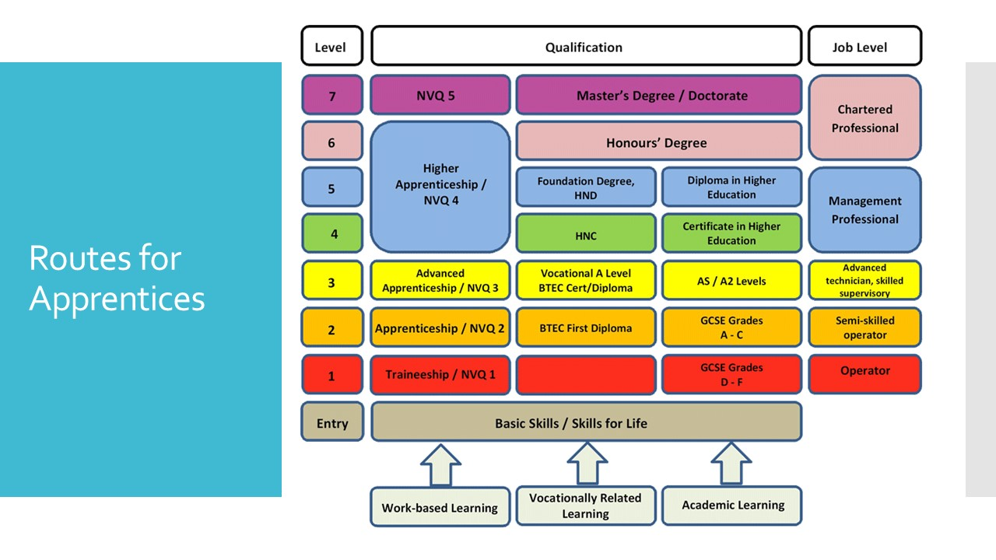
What options can I take?
Here are some popular options taken post 16 –
A Levels: Stands for Advanced Level. Students usually study 3 of these. There are a wide range of subjects to choose from, and they are studied across 2 years. They consist of more traditional methods of study and they are assessed through examination.
BTEC Qualifications: Students may take this if they are interested in a sector, job family or industry. It gives students a broader knowledge of a particular sector or industry. They are available in a range of sizes which are equivalent to one, two, or three A levels. They can be taken in combination with other qualifications.
Certificates: these enable you to develop transferable knowledge and skills through studying a particular industry or subject area. They are available in a range of subjects and can lead on to higher level study.
NVQs: provides students with skills to do a specific job and can be taken if you have a full-time job, or are on a course with a work placement.
Apprenticeships: An apprenticeship is a genuine job and under all circumstances an apprentice will be employed from day one. Apprenticeships combine practical training in a job with study
The above information (and information about other post 16 courses on offer), can be found on the following sites:
https://www.ucas.com/further-education/post-16-qualifications/post-16-qualifications-you-can-take
https://assets.publishing.service.gov.uk/government/uploads/system/uploads/attachment_data/file/787717/Guide-to-Apprenticeships-260219-LR.pdf
Where can I study in Havering and what sort of qualifications do they offer?

Campion Sixth Form School: https://thecampionschool.org.uk/ – A levels and a limited number of BTEC courses
Coopers and Coborn School: https://www.cooperscoborn.org.uk/ – A levels
Drapers Academy:
http://www.drapers-schools.com/ – A levels
Frances Bardsley Academy:
https://fbaok.co.uk/ – A levels and a limited number of vocational courses.
Harris Academy, Rainham
https://www.harrisrainham.org.uk/ - A levels and a limited number of vocational courses.
New City College, (NCC)
https://www.ncclondon.ac.uk/ - A levels and vocational courses
Sacred Heart Catholic School:
https://sacredheartofmary.net/
A Levels and a limited number of BTEC courses.
St. Edwards Church of England School:
http://www.stedwardsacademy.co.uk/
A levels
Open Events:
Coopers’ Company & Coborn School | Wednesday, 19th November – 4pm – 7pm
Drapers’ Academy | Tuesday, 11th November – 5pm – 7.30pm
Harris Academy Rainham | Thursday, 13th November – 5pm – 7.30pm
Sacred Heart of Mary Girls’ School | Thursday, 13th November – 6pm
St. Edward’s Church of England Academy | Thursday, 13th November – Time tbc on the website
The Campion School | Thursday, 9th October – 6 – 8pm
The Frances Bardsley Academy for Girls | Thursday, 20th November – time tbc on the website
NCC – Ardleigh Green Campus | Saturday, 22nd November – 10 – 2pm, all campuses  Saturday, 31st January 2026 – 10 – 2pm all campuses
NCC – Havering Sixth Form College | Saturday, 22nd November – 10 – 2pm, all campuses  Saturday, 31st January 2026 – 10 – 2pm all campuses
NCC – Rainham Campus | Saturday, 22nd November – 10 – 2pm, all campuses  Saturday, 31st January 2026 – 10 – 2pm all campuses
NCC – Redbridge Campus | Saturday, 22nd November – 10 – 2pm, all campuses  Saturday, 31st January 2026 – 10 – 2pm all campuses
Shenfield High School | Thursday, 13th November – 6 – 8pm
Brentwood County High | Thursday, 20th November – 5pm to 8pm
St. Martins School | Thursday, 16th October – 5.30 to 7.30pm
Barking & Dagenham College, Rush Green Campus | Saturday, 4th October – 10am
Fashion Retail College | Level 2 and 3 Open Day – Saturday 18th October. (Book for this now!)
East London Arts and Music (ELAM) | No information on the website yet.
London Academy of Excellence | Wednesday, 22nd October -
South Essex, Southend City College | Thursday, 25th September – 5pm to 8pm
South Essex, Thurrock College | Wednesday, 1st October – 5 – 8pm

Goals | Target Date | What do I need to do?

