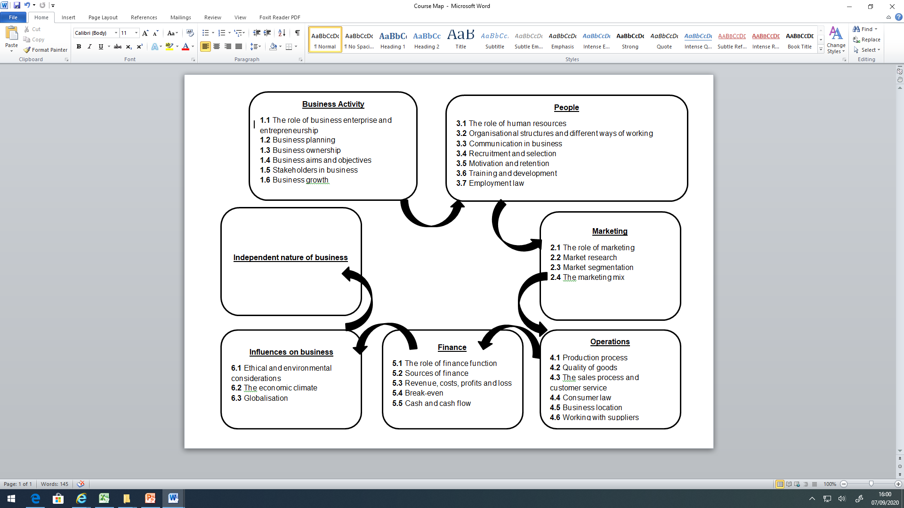
GCSE Business Studies
Year 10
Year 11

