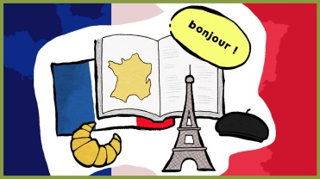
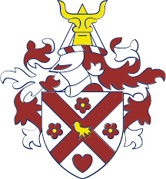
Curriculum Overview
Year 8 French

Why do we study Modern Foreign Languages?

At Emerson Park Academy we teach you MFL to:

- Equip you to understand and communicate in French or Spanish.
- Improve your competence in receptive and productive language skills.
- Provide a platform for you to express your ideas and personal interests through speech and writing.
- Develop your analytical and interpretive capacities.
- Broaden your understanding of how the English language works.
- Develop your memory, self-discipline and resilience.
- Provide an opening to other cultures and traditions.
- Enhance your intellectual curiosity towards local, national and global areas of interest.
- Expand your personal horizons.
- Provide you a good foundation for learning other languages.
- Equip you with skills to visit, study in or work in another country.

What will I be learning this year?

Term/Topic |  | What will I be learning? | Assessment
Autumn 1 – Holidays |  | Core language skills – Holiday destinations – Talking about School Holidays – Holiday activities – Using the past tense – Combining 2 (or more) tenses – Using negatives in past tense | Listening and Reading
Autumn 2 – Free time |  | TV programmes – Films – Reading – Using the internet– what you did yesterday evening | Writing (EWT)
Spring 1 – My identity |  | Personality-Relationships-Music- Clothing- Discussing your passion- Combing 3 tenses | Speaking (GC)
Spring 2 – My Area |  | Discussing your area – Describing where you live – Describing your home – Meals and mealtimes- What food you’re going to buy – Combining 3 tenses | Reading and Translation
Summer 1 –  Talent show |  | Talking about talent and ambition – Persuading others- Modal verbs-Rehearsing your talent-Talking about the best/worst | Listening and Reading
Summer 2 –  Vive la France |  | A cultural study of France – Similarities and differences between the UK and France – Discussing geographical features – Talking about famous French people – Discussing French inventions – Discussing Francophone cartoon characters | End of Year Exam

Curriculum Overview
Year 8 French

Why do we study Modern Foreign Languages?

At Emerson Park Academy we teach you MFL to:

- Equip you to understand and communicate in French or Spanish.
- Improve your competence in receptive and productive language skills.
- Provide a platform for you to express your ideas and personal interests through speech and writing.
- Develop your analytical and interpretive capacities.
- Broaden your understanding of how the English language works.
- Develop your memory, self-discipline and resilience.
- Provide an opening to other cultures and traditions.
- Enhance your intellectual curiosity towards local, national and global areas of interest.
- Expand your personal horizons.
- Provide you a good foundation for learning other languages.
- Equip you with skills to visit, study in or work in another country.

What will I be learning this year?

Term/Topic |  | What will I be learning? | Assessment
Autumn 1 – Holidays |  | Core language skills – Holiday destinations – Talking about School Holidays – Holiday activities – Using the past tense – Combining 2 (or more) tenses – Using negatives in past tense | Listening and Reading
Autumn 2 – Festivals |  | Discussing festivals and celebrations – Describing special events – Buying food – Describign future trips | Writing (EWT)
Spring 1 –  Freetime |  | TV programmes – Discussing technology – arranging going out – Freetime activities – Past tense practise – Combing 3 tenses | Speaking (GC)
Spring 2 – Yur Area |  | Discussing your area – Descring where you live – House chores – Daily Routine – Moving houses – Combinign 3 tenses | Reading and Translation
Summer 1 –  Sports |  | Talking about Sports – Opinions on Sport -Directions – Injuries and illness – Interviewing celebrities | Listening and Reading
Summer 2 –  Vive la France |  | A cultural study of France – Similarities and differences between the UK and France – Discussing geographical features – Talking about famous French people – Discussing French inventions – Discussing Francophone cartoon characters | End of Year Exam

