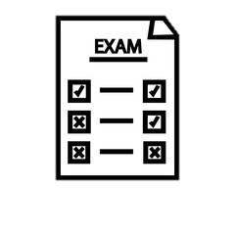
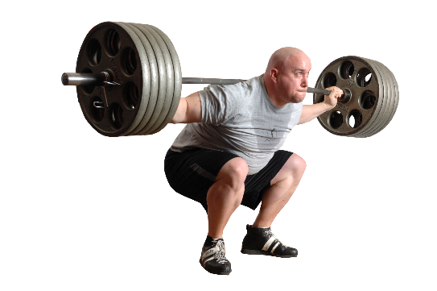

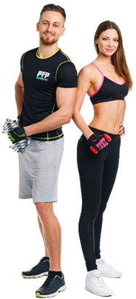
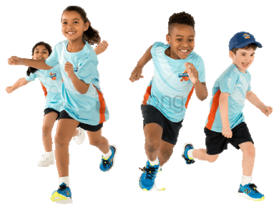


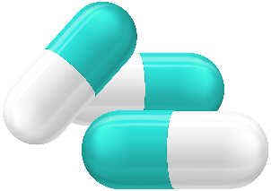
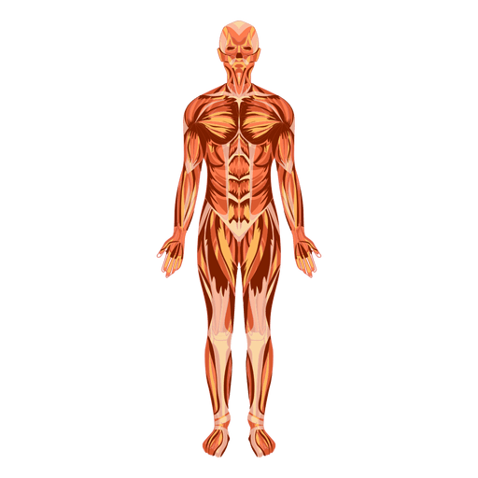
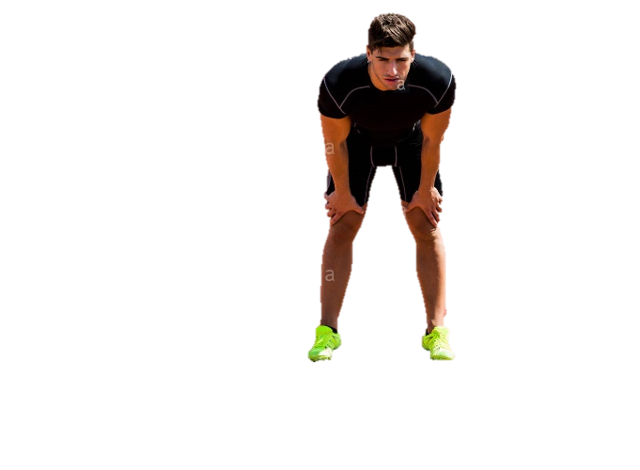
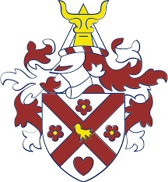
Physical Training
Learners will develop their knowledge and understand of the components of fitness required for physical activities and how each can be measured, be able to apply training principles to training programmes, along with knowing how to optimise training and prevent injury.
The Emerson Park Academy Physical Education Journey
GCSE PE Curriculum Map
Your GCSE Physical Education Journey starts here …
Year
10
Year
10
After x-mas
Year 11

Commercialisation
Learners will develop an understanding of commercialisation in sport, along with the positive/negative influences of media on participation and performances in sport.

Examination
There are two papers for GCSE PE., both of which are one hour written.
Paper 1 covers Applied Anatomy & Physiology and Physical Training.
Paper 2 covers Socio-Cultural Influences, Sports Psychology & Health, Fitness & Well-Being.

Short/Long Term Effects of Exercise
Learners will develop knowledge of the short and long-term effects of exercise on the body systems, and how these effects can impact on physical fitness and performance.

Diet & Nutrition
Learners will develop an understanding of the main components of a balanced diet, including the effects of these components and hydration on performers.

Health, Fitness & Well-Being
Learners will understand the benefits of participating in physical activity to health, fitness and well-being. Learners will know about the physical, emotional and social benefits as well as the consequences of a sedentary lifestyle.

Sport Psychology
Learners will understand the psychological factors that can affect performers.
Learners will also develop knowledge of the characteristics and classification of skilful movements, along with goal setting, guidance and feedback, and mental preparation.

Ethical & Socio-Cultural Issues
Learners will understand the ethics in sport including sportsmanship, gamesmanship and deviance. The effects of drugs in sport and why performers take them will be understood along with reasons for player violence.

Physical Activity & Participation
Learners will develop their knowledge and understanding of current participation trends, factors affecting participation and strategies to promote participation across a range of different groups in society.

Anatomy & Physiology
Learners will develop knowledge and understanding of the body systems, bones, muscles and movement planes that are important to physical activity.



SCAN HERE to see the OCR GCSE PE specification and the content you will cover in more detail.

A Level PE

BTEC Level 3 in Sport


SCAN HERE to see the requirements for the Practical Criteria and the Analysing & Evaluating Performance criteria.

GCSE Physical Education Breakdown

Examination – 60%
Practical Assessment – 30%
Analyse & Evaluate Performance – 10%

Practical Assessment (30%)

For GCSE PE, you will need to select THREE sports, with a maximum of two from either the Individual or Team category.

You will need to keep a competitive logbook of all the events that you do within your chosen sports. Your teacher will assess you in these sports. Any ‘off-site’ sports will need video evidence.

The list of available sports and more information of off-site video evidence can be found by scanning the QR Code above.

Analyse & Evaluate Performance (10%)

For one of your chosen sports, you will need to create a piece of coursework to demonstrate your ability to analyse and evaluate their own performance.

Learners will need to include:
- Analyse aspects of personal performance in a practical activity.
- Evaluate the strengths and weaknesses of the performance.
- Produce an action plan which aims to improve the quality and effectiveness of the performance.

Scan the QR Code above to find out more information.

