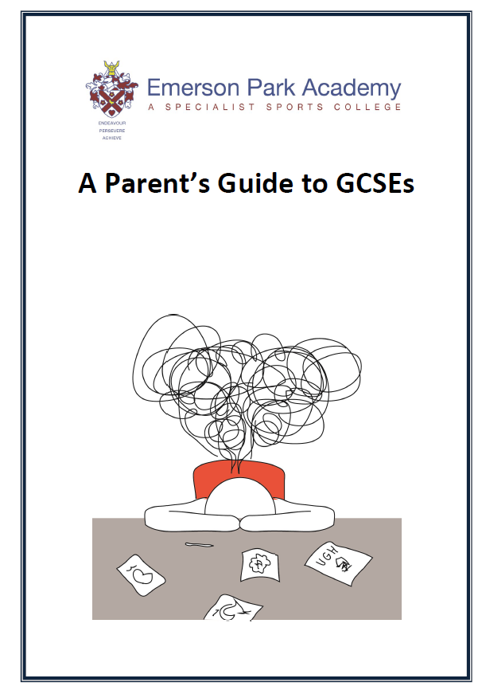

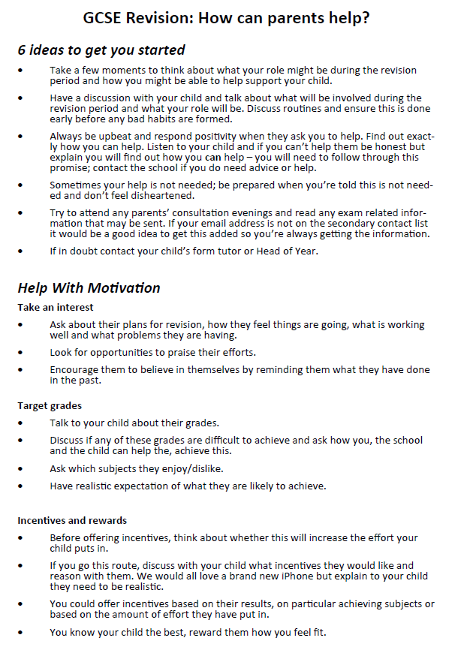

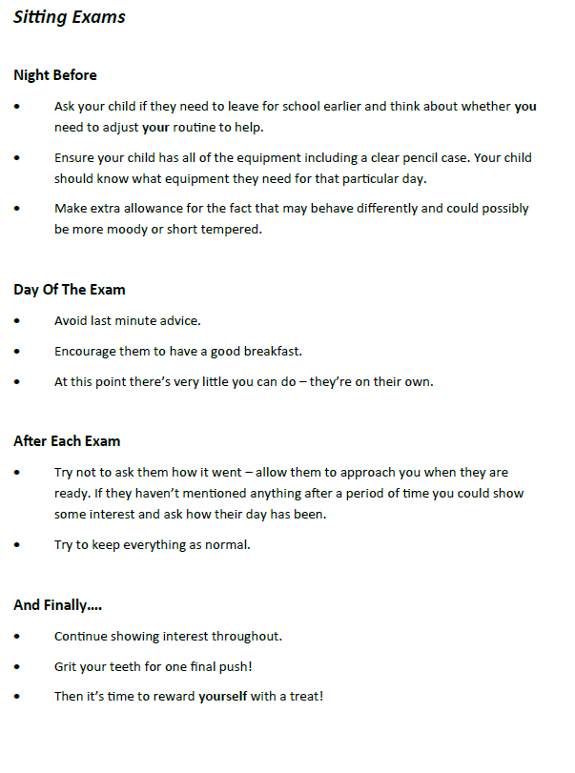

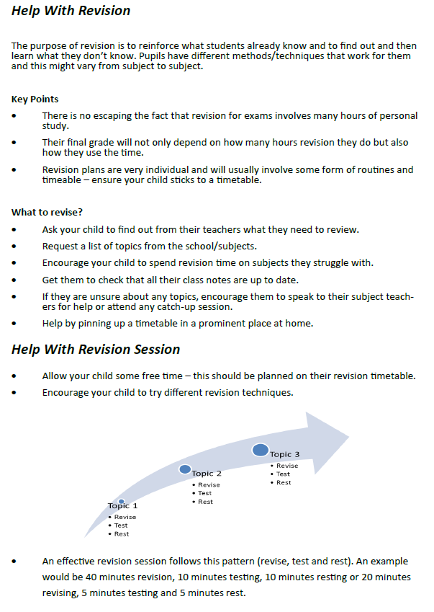

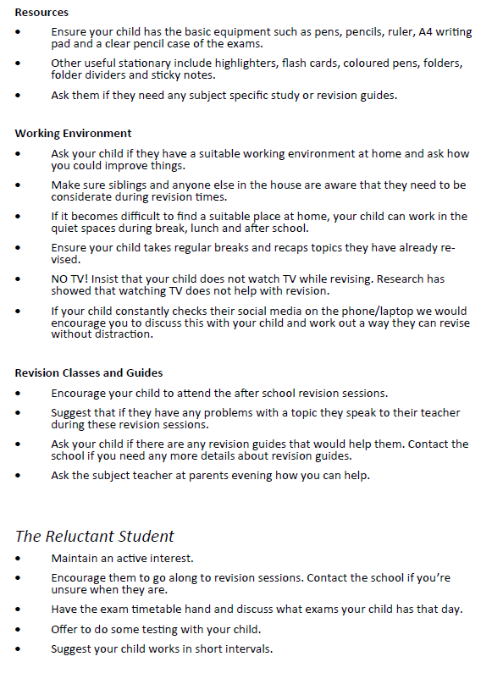

Examples of effective revision

- Repeat (retrieval practice)
- Desirable difficulty
- Spaced practice
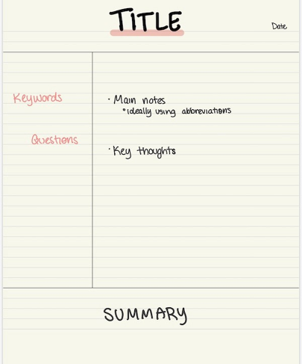

Retrieval
Brain dump  Choose a topic and write down as much as you can remember, without referring to your notes. Check your notes and see what you missed then try to fill the gaps without the notes. Check your notes a third time and add the missing information. | Flash cards  Write flashcards for each topic, in all subjects, then mix them up for the most effective revision. Check out the Leitner System for effective spacing and interleaving. Keep your flashcards simple – one question, one answer per card.
Map it out  Take an essay question or writing question and map out your answer, without writing a full response. Look at the mark scheme and decide if your plan meets the criteria. Do this for a number of questions, then choose one and write the full response. | Past papers  Ask your teacher for practice questions or exam papers. Complete them without notes in exam conditions, then check your answers and identify the gaps in your knowledge, so you can target your revision.
Quizzes  Write a set of questions and answers and ask someone else to test you. It's important to either write or say your answers aloud. Reading through quizzes in your head can give you a false sense of security. | Practise Introductions  For essay subjects, take a past exam question and practise writing effective introductions and conclusions. Look back at your notes and remind yourself of the important things to remember. Practise for different topics, texts and papers.
Thinking hard: reduce  Read a section of your notes then put them aside and reduce what you read to 3 bullet points, each one no more than 10 words. Look back at the notes and decide if you missed anything important. Hide the notes and write a fourth bullet point. | Thinking hard: transform  Read a paragraph from your notes or a text book and transform it into a diagram, chart or sketch – no words allowed. Look at a diagram in Science, for example, and transform it into a paragraph of explanation.
Thinking hard: connect  For each subject, consider the exam papers and group together questions that require the same technique to answer. Write down the requirements of each type. Find a previous example you've completed and identify where you've met the criteria. | Key vocabulary  For a particular topic, make a list of key vocabulary, then do the following: define each word; use each term in a sentence; create a question where the key word is the answer; identify other words which connect to each of the words in your list.

GCSE Grading Explained

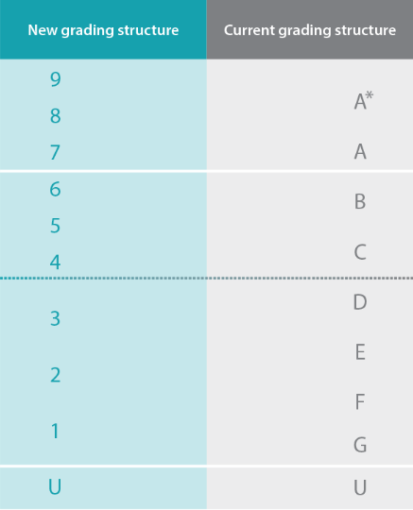
Old grading structure

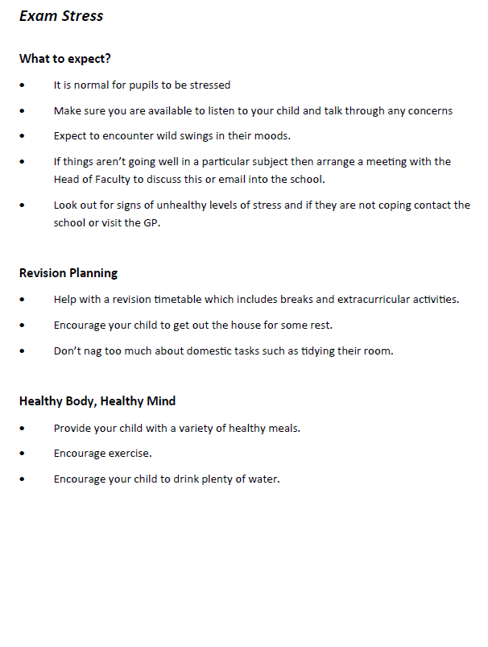

Elevate Education's
2026-27 Parent Webinar Series Schedule

AUTUMN TERM 2026 | SEPTEMBER 15 | GETTING (AND KEEPING) YOUR CHILD MOTIVATED  How to help your child develop and maintain a positive approach to studying.
AUTUMN TERM 2026 | SEPTEMBER 29 | HELPING YOUR CHILD MANAGE THEIR TIME  How to support your child in staying organised, meeting deadlines, and balancing school and fun.
AUTUMN TERM 2026 | OCTOBER 13 | HELPING YOUR CHILD IMPROVE THEIR NOTE TAKING  What their child's notes should look like and how they can help them study more efficiently.
AUTUMN TERM 2026 | NOVEMBER 10 | HELPING YOUR CHILD PREPARE FOR EXAMS  Maximising exam marks using practice papers and effective revision planning.
AUTUMN TERM 2026 | NOVEMBER 24 | HELPING YOUR CHILD STUDY WITH ADHD  How to help their child study with ADHD
AUTUMN TERM 2026 | DECEMBER 15 | BUILDING RESILIENCE IN YOUR CHILD  How to help their child bounce back from setbacks and navigate challenging times with confidence.

