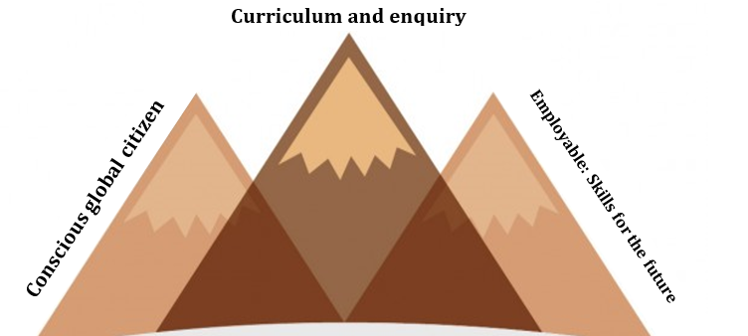

Conscious global citzen | The first aim of our geography curriculum intent is to nurture our students to become a ‘conscious global citizen’. We envision a ‘global citizen’ as a person who has cultural awareness and empathy for the human and natural environment. They understand the importance of sustainability and the preservation of the planet, as well as an appreciation of inequalities and social justice. Our students are challenged to think beyond the ‘self’ and contextualise their place in an increasingly global community. Our role is to promote tolerance and respect, which we achieve through providing space for our students to formulate opinions based on open discussion and reasoning. We make use of current affairs and clubs to promote this branch of our intent.
Curriculum and enquiry | Curriculum subject knowledge is the bedrock of our intent. All areas of the national curriculum guidelines are included to ensure our students are exposed to a suitable breadth of study. That being said, in order to better reach our other intent components we prefer to gradually build learning into themes as opposed to traditional ‘units’. This practice enables deeper thinking and a cross-curricular approach (which can be seen in each breakdown intent document). In addition, our curriculum is kept up to date with termly ‘Geography in the News’ lessons. We aim to be transformational in a student’s thinking and in order to achieve this we are sure to construct opportunities for independent enquiry to foster independent discovery, exploration and curiosity. Our students will be curious about the world and equipped with the skills to lead their own investigations.
Employable: skills for the future | Geography as a subject area is unrivalled in its breadth of skills to prepare young people for their careers and Higher Education. We are sure to exploit this potential. We continually promote the value of education which then enables us to embed the skills that prepare our young people for their next steps. We have embedded a plethora of general skills such as literacy, numeracy and organisational as well as the Geographical skills which we cover in every year where they are appropriate. Our methodology to track this progress uses digital spelling tests, numeracy assessments, clear deadlines and student-led presentations. Our assessments are varied in style to promote different career skills throughout their journey. We believe these skills mentioned create a fundamental framework for ensuring our students become competent and confident young citizens who will be greatly desired for future employment.

