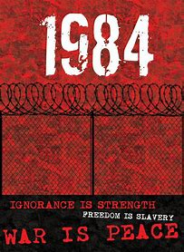 |  | DYSTOPIAN PROJECT  ‘1984’ by George Orwell
General questions when approaching literature:  - Is reading a passive experience?  - Is it an experience that conjures, that activates?  - Is there a point when literature denies a child more profound personal experiences by providing them with already conjured imaginary ones? |  | PERCEPTION AND SELF  How do we perceive our world?  What forces go into shaping the way we behave or perceive our world?  What forces distort or clarify our perceptions?  What role do we have or play in shaping our own experiences?  How accurate is our concept of self and the world?  VALUES AND JUDGMENT  How accurate are our value judgements?  As part of human definition, what values do we find valid and meaningful?  How does an author limit our concept of self and our ability to make judgements?  power and control  How much power or control can we achieve, if any?  What are the obstacles before us that prevent us from achievement?  Why does contemporary literature focus on our common humanity?
CHALLENGE: How can you apply your answers to ideas and examples from ‘1984’?

